(revised 4/26/2000)

Scanning Tunneling Microscope

Advanced Laboratory, Physics 407

University of Wisconsin
Madison, WI 53706

Abstract

A scanning tunneling microscope is used to demonstrate the principle of quantum mechanical tunneling between the microscope tip and the surface of a conducting sample. Measurements are made on a gold-coated holographic grating and a pyrolytic graphite sample. Since the apparatus is capable of atomic resolution, atomic features of the graphite surface can be directly observed. Mathematical filter algorithms are used to process the sample images and reduce the image noise. The bond angles and bond lengths of the graphite sample are determined.

1 OPERATING PRINCIPLES OF STM

1.1. How the STM Works

There are five scientific and technical processes or ideas that the STM integrates to make atomic resolution images of a surface possible. Each of these processes was used in other areas of science before the invention of the STM.

• The principle of quantum mechanical tunneling.

• Achievement of controlled motion over small distances using piezoelectrics.

• The principle of negative feedback.
• Vibration isolation.

• Electronic data collection.

This Chapter discusses each of these five concepts. The most detail is provided on the process of quantum mechanical tunneling, since this is the fundamental concept that allows the microscope to work. At the end of the discussion of all these concepts, one can see how they integrate to make an STM.

1.2. Ouantum Mechanical Tunneling

Quantum mechanical tunneling is not some obscure process that only occurs under extreme conditions in a crowded basement laboratory of a research university. Quantum mechanical tunneling explains some of the most basic phenomena we observe in nature. One example is the radioactive decay of plutonium. If quantum mechanical tunneling did not occur, plutonium would remain plutonium instead of changing into elements lower on the periodic chart. Plutonium converts to other elements when 2 neutrons and 2 protons are ejected from the nucleus because of tunneling. Even the fundamental force that binds atoms into molecules can be thought of as a manifestation of quantum mechanical tunneling. In this lab, we will look at how tunneling manifests itself in another way. We will attempt to understand how a single electron starts out in one metal and then reappears in another metal, even though they are not touching.
To begin, let's examine what electron tunneling means in the real world. Consider two pieces of metal. Metals are good conductors of electricity, i.e. electrons can move very easily and quickly from one end of the metal to the other. Imagine connecting one of the pieces of metal to the negative terminal of a battery and the other piece of metal to the positive terminal, as shown in Figure 2.1. If the metals are not touching, no current will flow through the battery. The electrons are free to move around the metal but cannot leave it. The electrons are analogous to water in a reservoir that is blocked by a dam. They can move about the reservoir but have no access to the river below. If the metals are brought together so that they touch, current will flow freely through the contacting area. The electrons have a free path from the negative terminal to the positive terminal of the battery. This current flow is analogous to opening up the gates of the dam and allowing the water to flow down the river into the ocean.

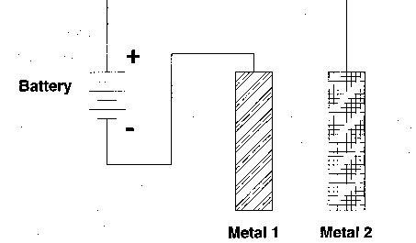

Figure 1.1. Two pieces of metal, each connected to a battery terminal. While the metals are well separated no current flows through the battery.

The unusual experimental feature of tunneling is this: when the metals are brought together, but are not quite touching, a small electric current can be measured. The current gets larger the closer the metals are brought together, until it reaches its maximum value when the metals are touching. The concept is analogous to making the dam thinner and thinner by removing cement and noticing that more and more water is leaking through the walls. However, there is a difference between the two analogies. The water physically moves through the pores between the cement, while the electrons do not move in the space between the metals: they just suddenly appear in the other side. The metals must be only 10 angstroms apart to produce detectable tunneling current. Figure 2.2. shows current as a function of the separation between metals [a]. Also plotted in this graph is the measured tunneling current if quantum mechanical tunneling did not occur [b]. The distances involved are so small that special tools are needed to adjust the distances or the small electric currents will not be detected. We will describe these tools in the section on piezoelectrics (see Section 2.4.).

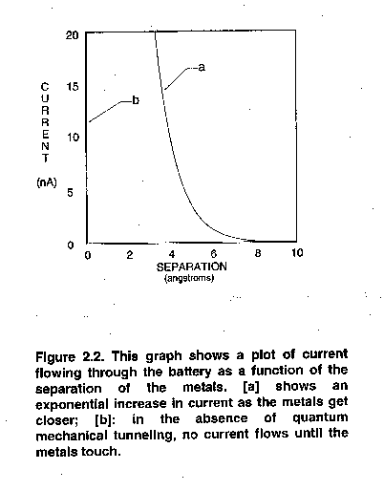
To understand why these small currents occur, the energies involved as the electron moves between the metals must be considered. An electron's energy can be split into two contributions: kinetic energy and potential energy. Kinetic energy (the energy of motion) is large for electrons moving fast and small for electrons moving slowly. Potential energy is the energy available for an electron to convert to kinetic energy if it moves along an electric field. Figure 2.3 plots the potential energy of the electron as it travels from one metal to the other metal. The potential energy shown neglects the complicated aspects of metals, including extra charges from atoms and other electrons on the metals, but does include the general concepts. The potential energy is lower in Metal 2 because this side is connected to the positive terminal of the battery (the terminal to which the electrons are attracted). There is also a large potential energy between the two metals. This is what tends to keep electrons inside their respective metal.

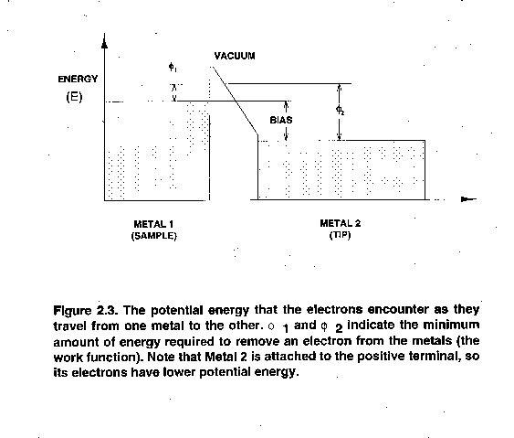
This picture shows that electrons are free to move around in their respective metals but cannot leave them. No electron in a metal has sufficient kinetic energy to go over the barrier. One of the basic tenets of quantum mechanics is that electrons have both a particle and a wave nature. So we should picture the electron not as a hard ball impinging on the barrier, but as a cloud. The size of the cloud is related to the wavelength of the electron (a few angstroms). When the cloud collides with the barrier, part of the cloud may penetrate it. For thick barriers, the cloud will be reflected like a hard particle (see Figure 2.4). For thin barriers, however, part of the cloud may penetrate the barriers and appear on the other side. This process is called tunneling because the electron does not have enough kinetic energy to travel over the barrier, but is able to exist on the other side (see Figure 2.5). It is as if the electron found a way to dig a tunnel through the barrier.

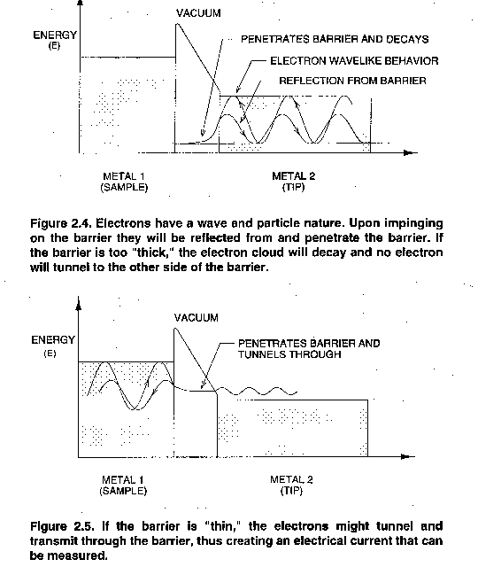
In the scanning tunneling microscope, one of the metals is the sample being imaged (sample) and the other metal is the probe (tip). The sample is usually flatter than the probe, as shown in Figure 2.6. If the probe is sharpened into a tip it will most likely have one atom at the end. All of the tunneling electrons will pass through this atom. As we will discuss later, this feature leads to the atomic resolution capabilities of the microscope.

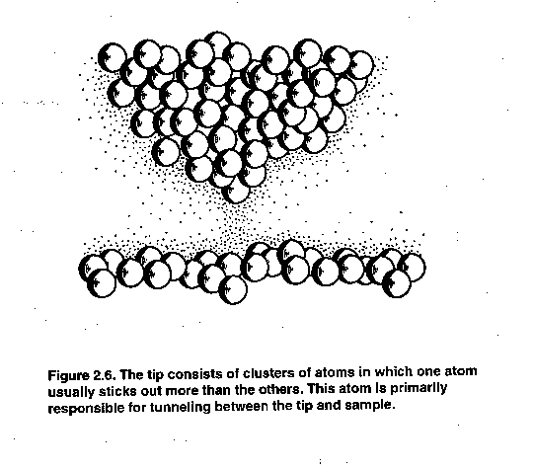

1.3. Ouantifying the Tunneling Process

Using Schrödinger's equation of quantum mechanics, we can actually predict how tunneling current increases as separation between two metals decreases. However, the final results of your tunneling experiments can be understood without knowing quantum mechanics. This more complete description is not necessary for understanding how the STM works; it therefore may be thought of as supplemental.

The Drude model of a metal states that the potential energy of a metal is given by the solid line in Figure 2.3. The energy of all the electrons in the metal is lower than the height of the wall. The difference in energy between the most energetic electron and the vacuum energy is called the workfunction and is denoted by the symbol Φ.

The wave nature of an electron, illustrated in Figures 2.4 and 2.5, is critical to explaining tunneling. The movement and shape of the electron wave is governed by Schroedinger's equation, which might be thought of as the quantum mechanical analog of Newton's equation of motion, F = ma.

In the STM, tunneling takes place between the tip and the sample. A complete description of the tunneling process requires a solution of the three-dimensional form of Schroedinger's equation, which has the general form:
(1.1)
where [H] and [E] are the Hamiltonian and total energy operators. The
operators are expressed as:

(1.2)

For our purpose it is sufficient to use a one-dimensional analysis, which for the Schroedinger
equation above is given by:

(1.3)

where the equation:

(1.4)

is the plane wave representation for an electron wavefunction of wavenumber
k = 2π/λ and angular frequency ω.

In addition, we assume a steady-state (time-independent) situation in which electrons of energy E(x, t) = E encountering a uniform potential barrier of height U(x, t) = U(x) are continuously flowing from one metal to the other. It is then necessary to solve only the one-dimensional steady-state Schroedinger equation, given by:

(1.5)

where E is the kinetic energy of the electron. Note that U(x) is the potential energy of the electron as a function of position, as shown in Figure 2.3. U(x) is smaller than the electron energy in the metals and larger than the electron energy in the barrier. For simplicity we can assume U(x) = U₀ a constant in the barrier.

In the metal, the general solution to the above equation is given by:

(Metal 1) (1.6)

(Metal 2) (1.7)

and in the barrier (the classically forbidden region) the solution is:

(barrier) (1.8)

Equations 1.6 and 1.7 show that the phase of the electron wavefunction varies uniformly in the metals. The wavelength is λ = 1/k. Higher energy electrons have a smaller wavelength. When a high energy electron wave encounters the boundary of the metal, it "leaks out" a small amount, as discussed in the previous section. The "intensity" of the electron wave decays as a function of distance from the boundary. Mathematically, the argument of the exponential function becomes real and the electron wavefunction decays. (For imaginary arguments, the wave function would have oscillatory behavior.)

To gain a quantitative insight into the electron tunneling phenomena, it is necessary to derive an expression for the transmission coefficient, i.e. the transmitted flux from the sample to the tip through the barrier of width L. The barrier is considered wide but finite, such that the electron wavefunction exponential decay in the barrier is significant. Furthermore, the electron wavefunction and its first derivative must be continuous (join smoothly) at the sample-barrier and tip-barrier boundaries to conserve energy and mass. If we set up a coordinate system in which the surface of the sample (Metal 1) is at x = 0 and the tip (Metal 2) is at x = L, and apply the boundary conditions for continuity:

(1.9)

(at the sample surface, x = 0) where D, the amplitude of the reflected wavefunction at the tip-barrier boundary, is neglected, since D << A, B, C. However, D is not insignificant at the tip-barrier boundary. At the tip-barrier boundary, x = L, continuity would require:

(1.10)

Solving for B/A at x = 0, by solving for C and substituting for it, we get:

(1.11)

where δ is 1/μ, A is the amplitude of the electron wavefunction in the sample surface incident on the barrier, and B represents the amplitude of the reflected wavefunction. The reflection coefficient (R) for the wavefunction is then defined as:

(1.12)

where represents the product of a complex number and its conjugate. In this case, it represents the relative intensities of the incident and reflected wavefunctions.

An electron incident at the barrier will either be reflected or transmitted through the barrier. In terms of probability or frequency of occurrence, R+T = 1, where R and T are the reflection and transmission coefficients. Thus:

(1.13)
and, therefore:
(1.14)

which indicates that, for an infinitely wide barrier, no electrons would be found in the barrier region. Nevertheless, dividing the first of the sample vacuum-barrier boundary conditions by A results in:

(1.15)

The probability of finding an electron in the barrier region at x = 0, due to quantum tunneling, is
given by:

(1.16)

To find the effective tunneling transmission coefficient, i.e. the relative
probability or frequency of occurrence of an electron tunneling out of the sample surface, across the sample-tip-barrier region, and into the tip, combine the tip-barrier boundary equations (at x L) and Equation 1.16 to get:

(1.17)

which produces the desired quantitative result:

(1.18)
where:
(1.19)

Substituting typical numbers of joules, kilograms, and joule-seconds, results in:
.

This formula shows that for each angstrom change in separation, the probability that an electron tunnels decreases by an order of magnitude. This demonstrates mathematically that tunneling current is indeed a sensitive measure of the distance between the tip and sample.

In the STM, one of the metals is the sample being looked at and the other metal is the probe. The sample is usually flatter than the probe, as shown in Figure 2.6. Because the probe is formed of atoms, if it is sharpened into a tip, it will most likely have one atom at the end of the tip. The spacing between atoms is about 3 angstroms. Therefore, any tunneling through atoms that are one atom back from the closest atom is a fraction of tunneling through the atom at the tip, as shown in Figure 2.6. Virtually all of the tunneling electrons will pass through the single atom closest to the surface. This feature produces the atomic resolution capabilities of the microscope.

2 Holographic Gold Grating: STM Magnification Experiment

To attain atomic resolution for gold, the STM signal has to be particularly low in noise. The very nature of the metal means that the electrons will be strongly delocalized between the atoms and there will only be small variations in the electron density with atomic position. The periodic modulations are typically on the order of 0.1 Å, so one should not expect to image gold atoms in normal room conditions. The purpose of this experiment is to introduce the concepts of tunneling and the extremely delocalized nature of electrons defined by the metallic state.

The first sample to examine is the gold-coated holographic grating. This sample is a single-period hologram with a sinusoidal spacing of 0.4 μm (4000 Å) . A hologram of the type seen on credit cards is composed of many such sinusoidal patterns of varying periods and orientations, which recreate the original image when viewing the diffracted or scattered light off the surface. This sample illustrates the piezoelectric tube scanner range and reinforces the level of magnification possible with the STM. The reference images are: grating1.img, grating2.img grating3.img, grating4.img, and grating5.img. These are images of 2400 lines/mm or about 0.4 μm (4000 Å) line spacing.

Procedure:

Head Preparation

1. Prepare either a PtIr or W tip and mount the tip.

2. Select the gold grating from the sample set and mount the sample.

3. Turn the Sample Position dial until the sample range indicator is close to the
middle of the range or the sample-tip spacing is less than 0.5 mm. Be careful not
to damage the tip and the sample.

Software Preparation

4. Load grating3.img (File/Load). This image is shown in Figure 4.9. Set the Scan
Delay (Configuration menu ) to 0.2 mS/Sample.

- In this scan you are monitoring height variations, so set the Data Type to Topographic (Configuration menu).

Electronics Preparation

6. Set the Bias Voltage to about 1 volt.
7. Set the Reference Current to 8 nA.
8. Set the Servo Loop Response for constant current mode of operation. Set the Gain
Close to maximum. Set the Filter close to maximum. Set the Time Constant to
minimum.

- Set the magnification to Xl.
- Set the X and Y offset slides at their middle range.
11. Press the Tunneling Current button to monitor tunneling current (it should read
about zero).

- 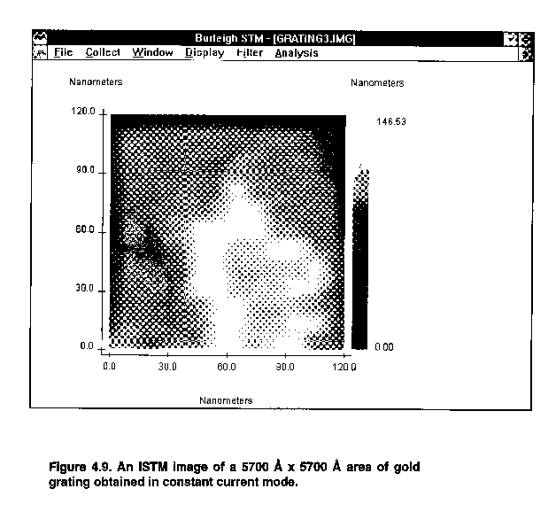

Tunneling

12. Press the Coarse Retract button momentarily to reset the motor controls.

13. Press the Auto Approach (Tunneling) button for approach and wait.

- Monitor the tunneling current until it reaches about 8 nA (equal to the reference
Current). If the tunneling current oscillates, reduce the Gain and Filter or increase
the Time Constant to stop the oscillation.

15. Once tunneling is achieved, start a unidirectional scan (Collect/ Scan
Unidirectional).

16. Collect images and save one at this range.

NOTE: Press C key on your keyboard to collect an image. Pressing C during a scan will capture the image at the end of the scan. Then you must use either Save or Save as command to save the image into the hard disk. To cancel image capture at the end of a scan, press C key again.

- Change the scanner range by turning the magnification dial. Set the software size
correctly in the menu by setting the Magnification knob (Configuration menu ).
Collect an image at each setting.

The large scan range should reveal a sinusoidal pattern on the surface with a period of 4167 Å and height variations of 1000 ± 100 Å, as shown in Figure 4.10. As you zoom in, the details of the gold crystallization process on the hologram should become apparent. The evaporated gold tends to rapidly diffuse to form random crystallites with grain sizes of approximately 60 to 100 Å. You can prepare a montage of all the collected scans (from the Windows display mode) to visualize an overall factor of magnification of at the highest magnification (such as in the images grating1.img through grating4.img).
Only for extremely quiet tunneling conditions will it be possible to discern atomic features. The best chance of obtaining atomic features is from the constant height mode at high scan speeds. Set the tunneling current to 4 to 5 nA and use a bias voltage of ~100 mV. You should compare this image to the constant height scans. The constant current mode cannot operate at as high a scan speed because it is limited by the response-time of the feedback loop; it is also more prone to acoustic noise than the constant height mode. The tip is extremely important in this regard, so you may want to try different tips. However, you should not expect to attain atomic resolution in this experiment. The main point here is to get an approximate determination of the maximum periodic variation in the electron density across the surface.

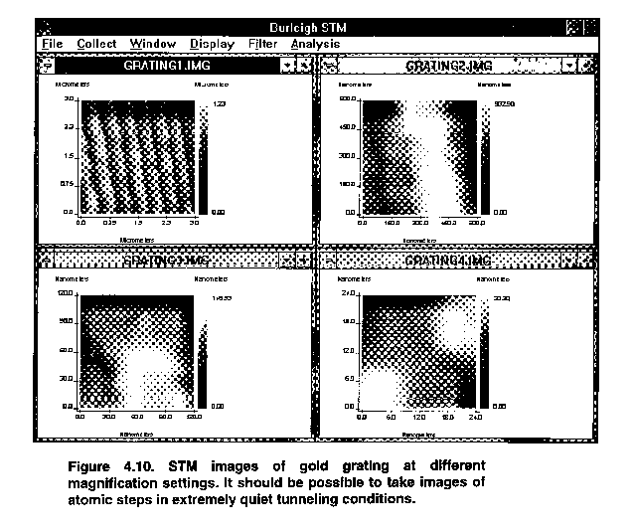
Load a representative image (File/Load). Use the cursor and draw a line through the data to visualize the fluctuations in tunneling current (Display/Cross Section). The current should be fairly constant across the surface, with variations of less than 0.1 Å in the tip position, to maintain constant current. The noise on your data may exceed this value, so you may want to filter the data-to reduce the noise level in the image. The main point is that the low degree of current variation across the surface illustrates the highly delocalized nature of electrons in metals. This study should be contrasted to that of graphite in the next section.

Questions

- Sometime during the use of the STM, the tip may have “crashed.” This is observable
as a sudden large change in the current. This occurs when there is a change in the
surface topology to which the feedback loop does not respond quickly enough and
the tip touches the surface. Calculate the effective resistance of the tunneling gap for
the conditions used in your experiment and compare that to the expected resistance
if the tip was in direct ohmic contact with the surface. The resistivity of gold is
. This comparison should graphically illustrate the tunneling effect you
are observing.

- As the temperature of metals is raised, the resistance to current flow increases.
Discuss the mechanism of resistance in metals and compare this mechanism to
electron tunneling. How would the temperature dependence of the two mechanisms differ?

- Because these experiments were conducted in air, adsorbed water, solvents, and
gases are undoubtedly on the surface. How do these molecules affect the tunneling
process and how might the tip perturb their distribution? Contaminants on the tip are also likely problems. Explain how this would affect the noise on your STM
experiment.

- Consider the problem of the electron source in these experiments. If the tip is not
scanned but left stationary over the surface, at a fixed distance that corresponds to a
tunneling current of 1 nA, calculate the number of electrons/second that flow
through the atoms that participate in the tunneling process between the gold and tip
surfaces.

Imaging Graphite

This lab should provide direct observation of atomic features of the graphite surface. It should also serve to contrast the difference in the spatial variation of electron density at the Fermi level between metals and semimetals. This reflects the nature of and the degree of overlap in the atomic orbitals involved.

Procedure:

Head Preparation

1. Prepare either a PtIr or W tip and mount the tip.

- Select the HOPG (graphite) from the sample set and mount the sample.

- Turn the Sample Position dial until the sample range indicator is close to the middle of the range or the sample-tip spacing is less than 0.5 mm. Be careful not to damage the tip and the sample. Make sure an optically flat portion of the sample is under the tip.

Software Preparation

4. Load graph1.img (File/Load).

5. Set the Scan Delay (Configuration menu ) to 0.0 mS/Sample.

- In this scan you are monitoring current variations, so set the Data Type to Current
(Configuration menu).
Electronics Preparation

7. Set the Bias Voltage to about -50 mV.

8. Set the Reference Current to 2 nA.

- Set the Servo Loop Response for constant height mode of operation. Set the Gain close to minimum. Set the Filter close to minimum. Set the Time Constant to maximum.

10. Set the magnification to X250.

11. Set the X and Y offset slides at their middle range.

- Press the Tunneling Current button to monitor tunneling current (it should read about zero).

Tunneling

13. Press the Coarse Retract button momentarily to reset the motor controls.

14. Press the Auto Approach (Tunneling) button for approach and wait.

- Monitor the tunneling current until it reaches about 2 nA (equal to the reference current). Adjust the Gain, Time Constant, and Filter, if necessary, to stop any tunneling oscillation.

- Once tunneling is achieved, start a unidirectional scan (Collect/ Scan Unidirectional). Scan over a few areas of the surface by using the X and Y slide bars to find a relatively flat region. The tip needs some conditioning to remove contaminants, so it may take a while for the tunneling current to settle.

NOTE: You may have to use the X and Y slide to find flat areas on the sample. When using these slides note that the image on the screen moves accordingly. However, it may take a few minutes for the tip to settle and for the drifts to become small. Be careful when using the X and Y slides. The total range of the slides always corresponds to the maximum scanner size. Moving the slides for large distances and frequent times will distort images. This distortion is due to electromechanical properties of PZT.

17. Collect images and save one at this range.
NOTE: Press C key on your keyboard to collect an image. Pressing C during a scan will capture the image at the end of the scan. Then you must use either Save or Save as command to save the image into the hard disk. To cancel image capture at the end of a scan, press C key again.

18. Change the scanner range by adjusting the magnification dial. Set the software
size correctly in the menu by setting the Magnification knob (Configuration
menu). Collect an image at each setting. Acquire images with effective sizes of
1000 Å, 500 Å, 100 Åand 20 Å.

- Attempt to acquire images in the constant current mode by setting the Gain close to maximum. Set the Filter close to maximum. Set the Time Constant to minimum. Set the scan delay (Configuration menu ) to 0.20 mSec and collect topographic data. Usually the best images are obtained in the constant height mode.

If the above procedures (steps 16-19) do not work, back off the tip and change tips. You should also cleave the surface again if repeated attempts don't bring out atomic details.

It should be possible to obtain images of graphite like those shown in Figure 4.17. If you get very stable graphite images, you should collect a number of scans, as a function of bias, to see how the appearance of the graphite lattice changes with bias. For a select scan, go into the display mode and use the cursor feature to determine the spatial variation in the constant current position of the tip. You may want to filter your data before you do this. Your data should show variations in surface topology of 1-2 Å. Variations may be larger in certain cases because of surface-tip interactions.

Contrast this result to the earlier study of gold surfaces (Section 2.1.1). For most images it should be possible to determine the hexagonal surface structure bond angles and approximate bond lengths of graphite. You should keep in mind the α and β types of carbon atoms in making your assignments. Multiple tip effects may also be observable. From your lowest noise image, it is particularly interesting to look at the surface structure using the 3-Dimensional perspective view display mode.

A sample graphite image taken at X250 is shown below. The scan is 30 Å x 30 Å acquired in constant height mode.

