

Parallel and Serial Bus Analysis
Lab Experiment
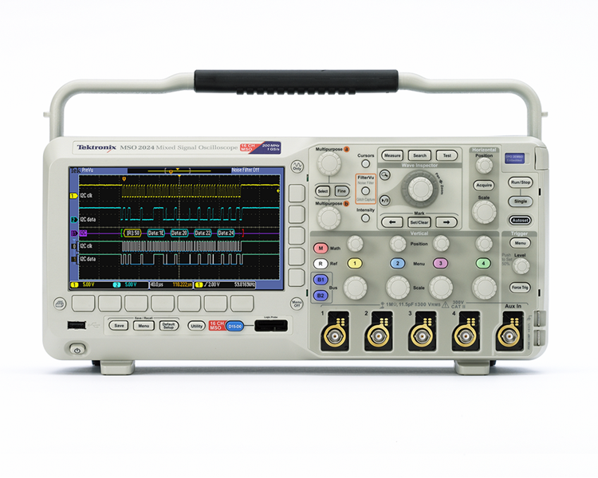

A collection of lab exercises to explore analysis of parallel and serial buses with a digital oscilloscope.

Copyright Notice and Reproduction Rights

©2009 Tektronix, Inc.

This document may be reprinted, modified and distributed in whole or in part for the limited purpose of training users or prospective users of Tektronix oscilloscopes and instrumentation. Any reproduction must include a copy of this page containing this notice.

Table of Contents

Laboratory Experiment Introduction 4
Objectives 4
Equipment List 4
Overview of Parallel Buses 5
Parallel Bus Analysis 6
Decoding and Analyzing Parallel Bus Traffic 6
Overview of the RS-232 Serial Bus 10
RS-232 Serial Bus Analysis 13
Decoding and Analyzing RS-232 Serial Bus Traffic 13
Final Exercise 16

Laboratory Experiment Introduction

Objectives
- Describe and demonstrate using the Tektronix MSO2000 series mixed signal oscilloscope to decode and analyze parallel buses.
- Describe and demonstrate using the Tektronix MSO2000 series mixed signal oscilloscope to decode and analyze the RS-232 serial bus.

Equipment List
- One Tektronix MSO2000 Series digital oscilloscope.
- One Tektronix DPO2COMP application module. It can be installed in either of the application module slots on the upper right corner of the front panel of the instrument. The oscilloscope should be OFF when the module is installed.
- One Tektronix P6316 logic probe.
- One Tektronix P2221 1X/10X passive probe.
- One Host/Device USB Cable.
- One Tektronix 878-0456-xx demonstration board.

Overview of Parallel Buses
Embedded systems can contain many different types of devices including microcontrollers, microprocessors, DSPs, RAM, EPROMs, FPGAs, A/Ds, D/As and I/O. These various devices have traditionally communicated with each other and the outside world using wide parallel buses. Even though many designs today use serial buses for communication, parallel buses are still common.
With a parallel architecture, each component of the bus has its own signal path. There may be multiple address lines, multiple data lines, a clock line and various other control signals. Address or data values sent over the bus are transferred at the same time over all the parallel lines.

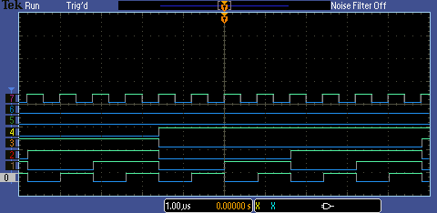
Parallel Bus Data Value:
1001 0000
Figure 1: Example of Parallel Bus Lines
One signal in the parallel bus is defined as the least significant digit and the other signals represent the other digits of the binary number up to the most significant digit. You can manually decode the bus data by evaluating each signal as high (1) or low (0) at each horizontal location. For example in the highlighted area above, the binary value for D7-D0 is 1001 0000.

If all signals are logic low, the bus state is 0000,0000 binary. If only the least significant digit is high, the bus state is 0000,0001 binary. If only the most significant digit is high the bus state is 1000,0000 binary and if all the signals are high the bus state is 1111,1111 binary.

Most engineers would prefer to use hexadecimal or “hex” notation, rather than binary. You can use the following chart to translate each group of 4 binary bits to a hex character:
Binary | Hex |  | Binary | Hex
0000 | 0 |  | 1000 | 8
0001 | 1 |  | 1001 | 9
0010 | 2 |  | 1010 | A
0011 | 3 |  | 1011 | B
0100 | 4 |  | 1100 | C
0101 | 5 |  | 1101 | D
0110 | 6 |  | 1110 | E
0111 | 7 |  | 1111 | F

Key Points to Remember
- Each component of a parallel bus has its own signal path.
- Address or data values sent over the bus are transferred at the same time over all the parallel lines.
- One signal in the parallel bus is defined as the least significant digit and the other signals represent the other digits of the binary number up to the most significant digit.

Exercise
- What is the binary value of the parallel bus below at the point highlighted?
- What is the parallel bus data value in hexadecimal notation?

Parallel Bus Analysis

Decoding and Analyzing Parallel Bus Traffic
- This section explores using the MSO2000 to decode and analyze a sample parallel bus.
  - Power up the MSO2000 Series oscilloscope by pressing the power switch on the lower left corner of the instrument.
  - Press the front panel Default Setup button to set the oscilloscope to a known state.
  - Plug the USB cable into the USB host port on the front of the MSO2000 Series oscilloscope and the USB device port on the demo board.
  - Verify the demo board’s green POWER LED is lit.
  - Connect the P6316 digital probe to the front panel connector on the MSO2000 Series oscilloscope.
  - Connect the probe’s Group 1 probe pod to the counter output connector, being careful to align the colored label with the signals on the right side of the connector.
  - Turn off channel 1 by pressing the yellow 1 front panel button twice.
  - Press the blue front panel D15-D0 button to turn on the digital input menu.
  - Press the D15-D0 On/Off bottom bezel button.
  - Press the Turn on D7-D0 side bezel button.
  - Press the front panel Autoset button. Autoset will automatically adjust the horizontal, vertical and trigger settings to obtain a usable display.
  - Press the blue front panel D15-D0 button to turn on the digital input menu.
  - Press the Height bottom bezel button until medium waveform size M is selected.
  - Press the Thresholds bottom bezel button. Notice that the digital threshold value has been set to 1.4V, which is a reasonable value for these digital signals.
  - Press the Menu Off button twice to remove the menus.
  - Set the horizontal Scale to 1 µs/div.
  - Press the Single button.
  - The oscilloscope display should now look like this:
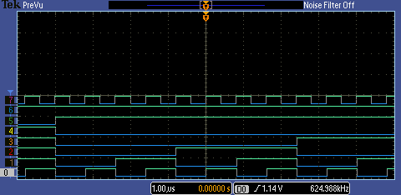

- The MSO2000 Series oscilloscope’s cursors can be used to automatically decode the individual points on a parallel bus. The following series of steps will use this functionality.
  - Press the Cursors front panel button once.
  - Using the multipurpose controls, position the cursors on two different points on the bus. The cursors may initially be off screen.
  - The cursor readouts in the upper right corner of the display provide automatic decoding of individual points on a parallel bus.
  - Press the Cursors front panel button once to turn cursors off.
- The MSO2000 Series oscilloscope can also be configured to automatically decode the entire parallel bus traffic. In the following series of steps, you will set up the oscilloscope to decode the bus.
  - Press the purple front panel B1 button to enable a parallel bus.
  - Press the Define Inputs bottom bezel button.
  - Using the multipurpose a control, set the Number of Data Bits to 8.
  - Press the Menu Off button once to clear the side menu.
  - Using the multipurpose a control, position the decoded bus waveform in the top half of the display.
  - Press the Menu Off button once to clear the menus.
  - Parallel bus decoding provides automatic decoding of all points on a parallel bus.
- In the previous steps, the oscilloscope is triggering on the rising edge of the D0 digital signal. (Autoset sets the trigger source to the lowest active channel.) The oscilloscope can also be set to trigger on parallel bus values.
  - Press the Trigger Menu button.
  - Press the Type bottom bezel button.
  - Turn the multipurpose a control fully counter-clockwise to select Bus triggering.
  - Press the Data bottom bezel button.
  - Turn the multipurpose a control fully clockwise to select the hex data word.
  - Using the multipurpose b control, select the value 10h. The oscilloscope is now set up to trigger on a parallel data value of 10h.
  - Press the Menu Off button twice to clear the menus.
  - Press the front panel Single button.
- You can now search the stored data for specific values as described in the following steps.
  - Press the front panel Search button.
  - Press the Search bottom bezel button.
  - Press the Search side bezel button until On is selected.
  - Press the Search Type bottom bezel button.
  - Turn the multipurpose a control fully counter-clockwise to select Bus searching.
  - Press the Data bottom bezel button.
  - Using the multipurpose a control, highlight the least significant digit of the Hex value.
  - Using the multipurpose b control, select the value X0h. Wave Inspector will now search for any data value that ends in “0”. Notice the white carets at the top of the display showing all bus values which match the search specification.
  - Press the Menu Off button twice to clear the menus.

Key Points to Remember
- Cursors can be used to automatically decode individual points on a parallel bus.
- The MSO2000 Series oscilloscope can be configured to automatically decode all points on a parallel bus.
- The MSO2000 Series can trigger on specific parallel bus data values.
- The MSO2000 Series can search on specific parallel bus data values and mark these values with special marks.

Exercise
- Using what you’ve learned and your current lab configuration, create the following display. Write down the parallel data value you used for your trigger.
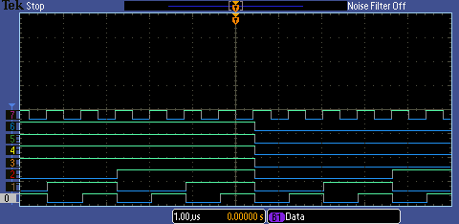

Overview of the RS-232 Serial Bus
RS-232 stands for Recommended Standard 232, a communication standard from the Electronic Industries Alliance (EIA), which was developed in the early 1960s for interconnection between teletype terminals and modems. The standard was updated to RS-232C in 1969 to specify electrical signal characteristics, mechanical interconnects, etc.
RS-232 provides two single-ended signals for point-to-point, full-duplex communication (simultaneous transmitted and received data). The standard does not specify character encoding, data framing, or protocols. It was designed for short-distance, low-speed serial data communication. Although the maximum cable length is not specified, a distance of less than 15 meters is recommended. The maximum data rate is not also specified, but rates <20 kb/s are recommended.
RS-232 data transmission is asynchronous, meaning that the clock is not transmitted and must be programmed in advance at both the transmitter and the receiver. Each character begins with a start bit, a high value which equates to a logic “0”. The character is comprised of 7 or 8 data bits, which must also be programmed. The data bits are transmitted in least-significant to most-significant bit order. The optional Parity bit is next. If not used, the bit is ignored. If used, the polarity must be programmed, and provides simple error detection by indicating whether there are an odd or even number of “1s” in the data word. Finally, the character is usually terminated in one to two stop bits.
Each RS-232 character can be encoded in various formats, but ASCII format is most commonly used. ASCII, short for American Standard Code for Information Interchange, is a 7-bit code (a range from 0 to 127) which is used to represent characters. Of the 128 possible codes, 95 (numbered 32 to 126) represent printable characters. Many of the remaining non-printing characters are control characters which control how text is processed. (Examples of control characters include backspace, tab, carriage return, and line feed.) Since most computer memories are based on 8-bit bytes, the eighth bit of the stored ASCII character can be used for parity, a simple error-detection scheme.

Chart of ASCII Characters

Key Points to Remember
The following is a brief listing of RS-232 characteristics:
- Point-to-point, serial data communication
- Full-duplex communication
- Asynchronous
- Short-distance (about 15 meters)
- Low-speed (<20 kb/s)
- 7 or 8 bits per character (ASCII format is most common format)
- Optional parity bit

Exercise
- In this exercise, you will manually decode RS-232 serial bus traffic. In this case, the RS-232 serial bus has a data rate of 9600 baud, meaning a bit is transmitted about every 100 µs. The signal is expected to consist of a start bit, 8 data bits, no parity bit, and a stop bit.
  - Decode the following serial data stream one bit at a time. Each red arrow points to a transmitted bit; the arrows are 100 µs apart. Remember, RS-232 inverts the signal when transmitting, so a high digital value represents ‘0’ and a low value represents a ‘1’. The start and stop bits have been skipped, meaning the arrows only point to data bits.
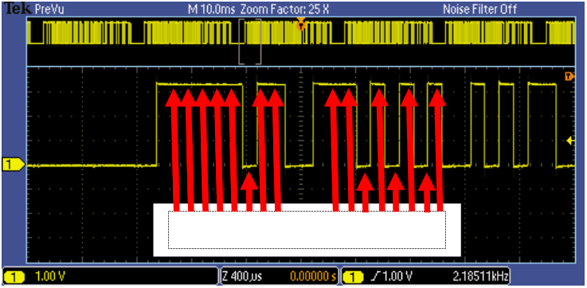
Write the bit stream here:
  - Now, RS-232 transmits data bits in order from least-significant to most-significant. Write the binary value for each bit stream of 8-bits here.

  - Write down the hexadecimal notation for each bit stream.
  - What ASCII characters does this serial data stream represent?

RS-232 Serial Bus Analysis

Decoding and Analyzing RS-232 Serial Bus Traffic
- With the DPO2COMP application module installed, the MSO/DPO2000 Series oscilloscope can trigger, decode and search RS-232 serial bus traffic. For this lab exercise, the RS-232 serial signal on the demo board will be used. In the following steps, you will decode and analyze an RS-232 serial bus.
  - Press the front panel Default Setup button to set the oscilloscope to a known state.
  - Connect the P2221 1X/10X passive probe to the channel 1 input and set the 1X/10X slider switch to the 10X position.
  - Connect the channel 1 probe tip to the RS-232 signal on the demo board and the probe ground lead to the demo board GND (ground) clip.
  - Using the front panel Trigger Level control, set the trigger level to about 1 V.
  - Set the horizontal Scale to 10 ms/div.
  - Press the front panel Single button.
  - Press the Menu Off button to remove the menu.
  - 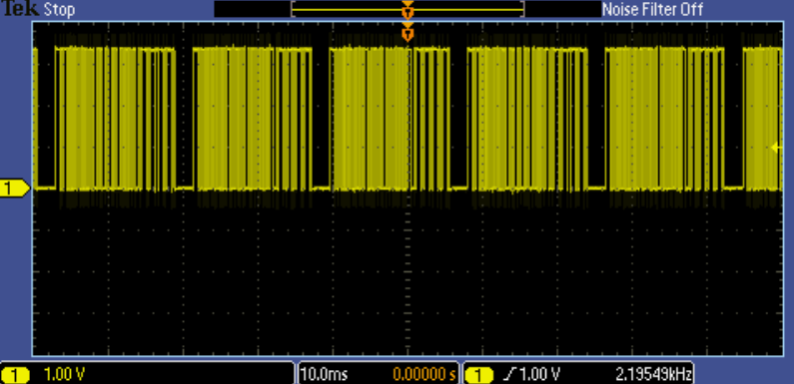The RS-232 serial signal looks about like this.
- The MSO2000 Series oscilloscope can be used to automatically decode the serial bus data. In the following steps, you’ll set up the oscilloscope to decode the RS-232 serial data stream.
  - Turn the inner Wave Inspector knob clockwise until the zoom factor (displayed at the top of the display) is set to 25X.
  - Press the purple front panel B1 button to enable bus decoding.
  - Press the Bus B1 bottom bezel button.
  - Using the multipurpose a control, select RS-232.
  - Serial bus decoding provides automatic decoding of all data values on the RS-232 serial signal.
  - Press the Thresholds bottom bezel button. Notice that the Tx(1) digital threshold has been set to the same value as the edge trigger level.
  - The display format for the decoded data defaults to hexadecimal, but binary and ASCII formats are also available. Press the Bus Display bottom bezel button and press the ASCII side bezel button.
  - Press the Event Table bottom bezel button.
  - Press the Event Table side bezel button until On is selected.
  - The Event Table display of this RS-232 serial signal looks like this:
(invisible characters such as spaces appear as diamonds in the decoded display)
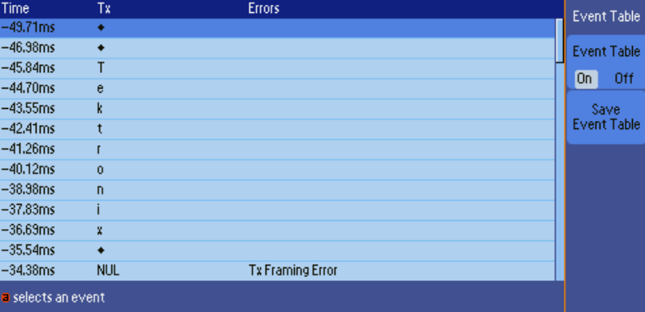
  - The Event Table shows all captured transmit (Tx) data packets in a tabular view. Packets are time stamped and listed consecutively.
  - When you are done, press the Event Table side bezel button until Off is selected
- In the previous steps, the oscilloscope was just triggering on a rising edge of the channel 1 signal. The oscilloscope can also be set up to trigger on serial bus values, such as the ‘T’ character which is demonstrated in the following steps.
  - Press the Trigger Menu button.
  - Press the Type bottom bezel button. Turn the multipurpose a control fully counter-clockwise to select Bus triggering.
  - Press the Trigger On bottom bezel button. Using the multipurpose a control, select Tx Data.
  - Press the Data bottom bezel button.
  - Press the Data side bezel button. Turn the multipurpose a control until the ASCII character is highlighted. Using the multipurpose b control, select the capital ‘T’ character.
  - Press the front panel Single button to capture the RS-232 serial data.
  - Press the Menu Off button twice to clear the menus. The oscilloscope has triggered on the serial packet that represents the ASCII character ‘T’.
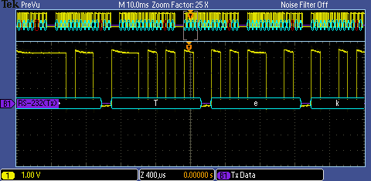
- In the next series of steps, you’ll use Wave Inspector to search for specific serial bus values.
  - Press the Search front panel button.
  - Press the Search bottom bezel button. Press the Search side bezel button to select the On state.
  - Press the Search Type bottom bezel button. Use the multipurpose a knob to select the Bus option.
  - Press the Search For bottom bezel button. Use the multipurpose a knob to select the TxData option.
  - Press the Data bottom bezel button.
  - Press the Data side bezel button. Use the multipurpose a button to select the ASCII option in the side bezel menu. Use the multipurpose b button to select an ASCII “T” character.
  - Press the Menu Off button twice to remove the menus.
  - Notice that several instances of a T have been found as indicated by the white carets.
  - Press the ← and → arrows to step between the T characters.
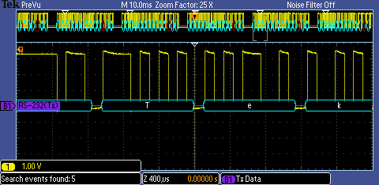

Key Points to Remember
- It is difficult to manually decode serial bus data. The MSO/DPO2000 Series can be used to decode this data automatically.
- The MSO/DPO2000 Series oscilloscope can trigger on specific serial data values.
- Wave Inspector can be used to search for specific serial data values.

Exercise
- Using what you’ve learned and your current lab configuration, set up the oscilloscope to trigger on serial data value 78 hex.
  - Write down your steps here.
  - How many instances of data value 78 hex are in your acquisition?

Final Exercise
- In which type of bus does each component of the bus have its own signal path?
  - Serial
  - Parallel
- The hexadecimal notation of 1000,0000 binary is _________________.
- RS-232 data transmission is synchronous, meaning that the clock is transmitted.
  - True
  - False
- The RS-232 mandatory Parity bit provides a simple error detection method by indicating whether there are an odd or even number of “1s” in the data word.
  - True
  - False
- The ASCII code 35 (hex) is used to indicate which character?
  - 5
  - A
  - T
  - “
- Using what you have learned and your current lab configuration, press the oscilloscope front panel Default Setup button and then create the following display.
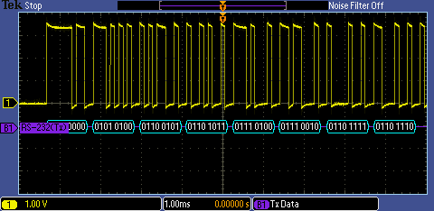
  - Using the oscilloscope, determine the hexadecimal notations for the serial packets on the display.
  - Using the oscilloscope, determine the ASCII characters represented by these packets.
  - How many serial packets representing the ASCII character “n” are in your acquisition?
  - Set the horizontal scale factor to 4 ms/div. Set up the oscilloscope to trigger on ASCII character “k”. What is spelled out by the RS-232 bus packets?
Tektronix products are covered by U.S. and foreign patents, issued and pending. Information in this publication supersedes that in all previously published material. Specification and price change privileges reserved. TEKTRONIX and TEK are registered trademarks of Tektronix, Inc. All other trade names referenced are the service marks, trademarks or registered trademarks of their respective companies.
06/09 GB/WWW 3GW-24325-0

