

Introduction to Oscilloscopes
Instructor’s Guide
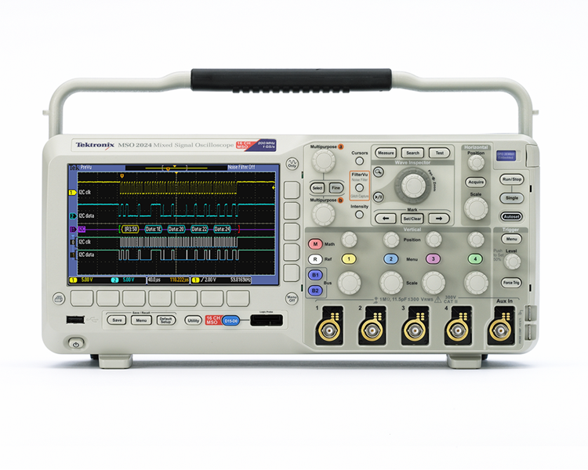

A collection of lab exercises to introduce you to the basic controls of a digital oscilloscope in order to make common electronic measurements.

Copyright Notice and Reproduction Rights

©2009 Tektronix, Inc.

This document may be reprinted, modified and distributed in whole or in part for the limited purpose of training users or prospective users of Tektronix oscilloscopes and instrumentation. Any reproduction must include a copy of this page containing this notice.

Table of Contents

Laboratory Experiment Instructor’s Guide Introduction 4
Objectives 4
Laboratory Experiment Introduction 4
Objectives 4
Equipment List 4
Overview of an Oscilloscope 5
Introduction 5
Performance Terms and Considerations 6
Initial Setup and Screen Explanation 7
Creating a Stable Display 7
Screen Explanation 8
Instrument Controls 10
Vertical Controls 11
Introduction 11
Vertical Position/Scale Controls 11
Horizontal Controls 12
Introduction 12
Horizontal Position/Scale Controls 12
Setting the Record Length 13
Trigger Controls 15
Introduction 15
Trigger Level Control 15
Trigger Menu 16
Oscilloscope Measurements 18
Introduction 18
Manual Measurements 19
Cursor Measurements 20
Automated Measurements 21
Final Exercise 23

Laboratory Experiment Instructor’s Guide Introduction

Objectives
- The purpose of this Instructor’s Guide is to:
  - Expand the training steps with additional oscilloscope screen and front panel images to assist students who may have questions.
  - Provide answers for each exercise.
- Instructor’s notes are in bold blue text.

Laboratory Experiment Introduction

Objectives
- Understand the block diagram and basic controls of a digital oscilloscope.
- Setup an oscilloscope for a stable display of the applied signal.
- Make common electronic measurements with a digital oscilloscope.

Equipment List
- One Tektronix MSO2000 or DPO2000 Series digital oscilloscope.
- One Tektronix P2221 1X/10X passive probe.
- One Host/Device USB cable.
- One Tektronix 878-0456-xx demonstration board.

Overview of an Oscilloscope

Introduction
An oscilloscope is an electronic test instrument that displays electrical signals graphically, usually as a voltage (vertical or Y axis) versus time (horizontal or X axis) as shown in figure 1. The intensity or brightness of a waveform is sometimes considered the Z axis. There are some applications where other vertical axes such as current may be used, and other horizontal axes such as frequency or another voltage may be used.

Oscilloscopes are also used to measure electrical signals in response to physical stimuli, such as sound, mechanical stress, pressure, light, or heat. For example, a television technician can use an oscilloscope to measure signals from a television circuit board while a medical researcher can use an oscilloscope to measure brain waves.

Oscilloscopes are commonly used for measurement applications such as:
- observing the wave shape of a signal
- measuring the amplitude of a signal
- measuring the frequency of a signal
- measuring the time between two events
- observing whether the signal is direct current (DC) or alternating current (AC)
- observing noise on a signal

Figure 1: Typical Oscilloscope Display
An oscilloscope contains various controls that assist in the analysis of waveforms displayed on a graphical grid called a graticule. The graticule, as shown in figure 1, is divided into divisions along both the horizontal and vertical axes. These divisions make it easier to determine key parameters about the waveform. In the case of the MSO/DPO2000 Series oscilloscope, there are 10 divisions horizontally and 8 divisions vertically.
A digital oscilloscope acquires a waveform by conditioning the input signal in the analog vertical amplifier, sampling the analog input signal, converting the samples to a digital representation with an analog-to-digital converter (ADC or A/D), storing the sampled digital data in its memory, and then reconstructing the waveform for viewing on the display.

Figure 2: Typical Digital Oscilloscope Block Diagram

Performance Terms and Considerations
There are many ways to specify digital oscilloscope performance, but the most important are bandwidth, rise time, sample rate, and record length.

Bandwidth
Bandwidth is the first specification to consider. Bandwidth is the frequency range of the oscilloscope, usually measured in Megahertz (MHz). It is the frequency at which the amplitude of the displayed sine wave is attenuated to 70.7% of the original signal amplitude.

When measuring high-frequency or fast rise-time signals, oscilloscope bandwidth is especially critical. Without adequate bandwidth, an oscilloscope will not be able to display and measure high-frequency changes. It is generally recommended that the oscilloscope’s bandwidth be at least 5 times the highest frequency that needs to be measured. This “5-times rule” allows for the display of the 5th harmonic of the signal and assures that measurement errors due to bandwidth are minimized.
$$\text{oscilloscope} \text{bandwidth} ≥ 5^{\text{th}} \text{harmonic} \text{of} \text{signal}$$

Example: If the signal of interest is 100 MHz, the oscilloscope would need a bandwidth of 500 MHz.

Rise Time
The edge speed (rise time) of a digital signal can carry more high-frequency content than its repetition rate might imply. An oscilloscope and probe must have a sufficiently fast rise time to capture the higher frequency components, and therefore show signal transitions accurately. Rise time is the time taken by a step or a pulse to rise from 10% to 90% of its amplitude level. There is another “5-times rule” that recommends that the oscilloscope’s rise time be at least 5 times faster than the rise time of the signal that needs to be measured.
$$\text{oscilloscope} \text{rise} \text{time} ≤ \frac{\text{signal} \text{rise} \text{time}}{5}$$

Example: If the signal of interest has a rise time of 5 μsec, then the oscilloscope rise time should be faster than 1 μsec.

Sample Rate
Digital oscilloscopes sample the input signals at a frequency called the sample rate, measured in samples / second (S/sec). To properly reconstruct the signals, Nyquist sampling requires that the sample rate be at least twice the highest frequency being measured. That’s the theoretical minimum. In practice, sampling at least 5 times as fast is generally desirable.
$$\text{sample} \text{rate} ≥ 5∗ f_{\text{Highest}}$$

Example: The correct sample rate for a 450 MHz signal would be ≥ 2.25 GS/sec.

Record Length
Digital oscilloscopes capture a specific number of samples or data points, known as the record length, for each acquired waveform. The record length, measured in points or samples, divided by the sample rate (in Samples/second) specifies the total time (in seconds) that is acquired.
$\text{acquired} \text{time} =\frac{\text{record} \text{length}}{\text{sample} \text{rate}}$
Example: With a record length of 1 Mpoints and a sample rate of 250 MS/sec, the oscilloscope will capture a signal 4 msec in length.

Exercise
What minimum oscilloscope performance is required to properly capture 2 msec of a 1 V_{pk-pk} , 250 MHz sine wave?
- Bandwidth: Minimum Bandwidth = (5)x(250 MHz)
Minimum Bandwidth = 1,250 MHz
Minimum Bandwidth = 1.25 GHz

- Sample Rate: : Minimum Sample Rate = (5)x(250 MHz)
Minimum Sample Rate = (5 Samples/cycle)x(250 M cycles/sec)
Minimum Sample Rate = 1,250 MS/sec
Minimum Sample Rate = 1.25 GS/sec
- Record Length: Record Length = (1.25 GS/sec)x(2 msec)
Record Length = 2.5 M samples or 2.5 M points

Initial Setup and Screen Explanation

Creating a Stable Display
- The following steps will describe how to automatically create a stable oscilloscope display using a
1 kHz, 5 V_{pk-pk} square wave.
Location of buttons and connectors for this lab section:
  - Power up the MSO/DPO2000 Series oscilloscope by pressing the power button on the lower left corner of the instrument.
  - Press the front panel Default Setup button to set the oscilloscope to a known starting point.
  - Connect a P2221 1X/10X passive probe to the channel 1 input. To connect a BNC connector, push and turn the probe connector until it slides on the connector. Then, turn the locking ring clockwise to lock the connector in place.
  - Use the probe slide switch to set the probe attenuation to 10X.
  - Attach the probe’s alligator style ground lead to the ground connector on the lower right corner of the oscilloscope.
  - Attach the probe tip to the PROBE COMP connector just below the ground lead connector. The PROBE COMP connector provides a 1 kHz square wave that this lab will use to demonstrate the operation of an oscilloscope.
  - Press the front panel Autoset button to cause the oscilloscope to automatically set the vertical, horizontal and trigger settings for a stable display of the PROBE COMP 1 kHz square wave.

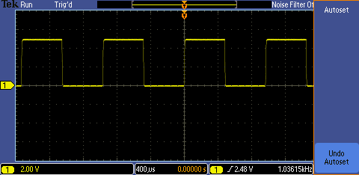

Key Points to Remember
- To return the oscilloscope to a known state, press the Default Setup button.
- The Autoset button adjusts the vertical, horizontal and trigger settings such that four or five cycles of the waveform are displayed with the trigger near the middle of the screen.

Screen Explanation
- Following is a review of the oscilloscope’s display.
Explanation of the oscilloscope display:

  - The channel 1 vertical axis button is yellow and most of the elements on the screen that relate to the channel 1 signal are yellow in color.
  - On the display, the following items are yellow to indicate they are associated with channel 1:
- waveform
- waveform ground level indicator (center left of screen)
- vertical scale readout (bottom left of screen 2.00 V)
  - The channel 2, 3, and 4 vertical axis buttons are blue, magenta and green respectively. The display uses the color coding of these channels just as it does for the yellow of channel 1.

  - As can be seen on the oscilloscope screen, the square wave extends up about 2 ½ divisions on the display graticule from the ground level indicator. Since the vertical scale factor is 2 Volts/div, this indicates the signal’s positive peak is at about
+5 V.

  - One cycle of the waveform is about 2 ½ divisions wide. The time per horizontal division is indicated by the horizontal scale readout which in this case is 400 µsec/div (bottom center of the display). At 400 µsec/div, the period of the signal is about 1 msec and the frequency is about 1 kHz.
  - Finally, the trigger frequency readout indicates the channel 1 signal has a frequency of about
1 kHz as shown in the bottom right corner of the display.

Key Points to Remember
- The input channels are color coded. Onscreen channel information is in that channel’s color, including the waveform, ground indicator, and vertical scale factor (Volts/div).
- The amplitude of the signal can be determined by multiplying the number of vertical divisions the waveform spans times the vertical scale factor.
- The signal period can be determined by multiplying the number of horizontal divisions times the horizontal scale factor.
- Signal frequency is calculated by dividing 1 by the signal period.

Exercise
Based on the display shown here, answer the following questions:
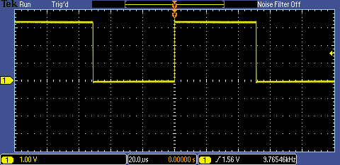

What is the peak-to-peak voltage of the signal?
About 3.3 V. The signal extends up about 3.3 divisions on the display graticule with a vertical scale factor of 1 V/div.
What is the voltage of the signal’s positive peak? Negative peak?
The signal extends up about 3.3 divisions from the ground level indicator. Therefore,
the positive peak is about 3.3 V and the
negative peak is 0 V.

What is the period and frequency of the signal?
One cycle of the waveform is 5 divisions on
the display graticule. Since the horizontal
scale factor is 20 μsec, the period of the signal
is 100 μsec and the frequency is 10 kHz.

Instrument Controls
The controls of a typical oscilloscope can be grouped into three major categories: vertical, horizontal, and trigger. These are the three main functions that are used to set up an oscilloscope. The use of these controls is described in the following sections of this lab.
Here are a few hints that will make using the oscilloscope controls easier:
- Decide if the task is related to oscilloscope’s vertical axis (typically voltage), horizontal axis (typically time), trigger, or some other function. This will make it easier find the correct control or menu.
- Pressing a front panel button will usually display a first-level menu at the bottom of the display. The menu items are logically prioritized from left-to-right. If they are selected in that order, the setup should be straightforward.
- In most cases, pressing the button underneath a menu item at the bottom of the display results in a second-level menu at the side of the display. These menu items are logically prioritized top-to-bottom.
- If a small orange a or b is displayed on the screen, it indicates the front panel Multipurpose a or b controls may be used to change that menu selection.
- Pressing the Menu Off button turns off one menu level at a time until all menus and readouts are removed.

Exercise
The oscilloscope’s vertical axis controls are typically used to control which parameter?
Voltage.

Vertical Controls

Introduction
The vertical controls set or modify the vertical scale, position, and other signal conditioning for each of the analog input channels.

There is a set of vertical controls for each input channel. These controls are used to scale, position, and modify that channel’s input signal so it can be viewed appropriately on the oscilloscope display. In addition to the dedicated vertical controls for each channel, there are also buttons to access the math menu, reference menu and bus menus.

Vertical Position/Scale Controls
- The following steps will explore the use of the vertical axis position and scale front panel controls.
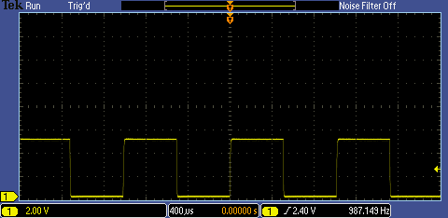
  - Use the channel 1 vertical Position knob to position the waveform near the bottom of the display and notice the ground level indicator also moves.
The vertical position control moves the waveform up and down. It is generally used to align the waveform with the vertical divisions on the graticule. Position is generally a graphical display function only and does not affect the acquired waveform data.
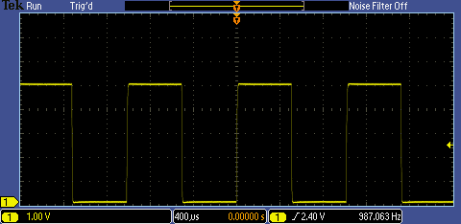
  - Use the channel 1 vertical Scale knob to change the vertical scale from 2 V/div to 1 V/div.
The vertical scale (Volts/division) control adjusts the height of the waveform on the display. Generally, the vertical scale control changes the settings of the input amplifier and/or attenuator and does affect the acquired waveform data. Because the vertical scale controls the amplitude of the signal going into the ADC, the highest-resolution measurements are achieved when the signal almost fills the screen vertically without going off screen.

Key Points to Remember
- The vertical position knob controls the position of the waveform on the vertical axis.
- The vertical scale knob controls the amount of voltage represented by a vertical division on the graticule.

Exercise
To make the highest-resolution measurement, what vertical scale should be used to measure the PROBE COMP square wave? Why?
1 V/div. The 1V/div setting causes the signal to fill as much of the vertical axis as possible without going off screen. This means the signal going into the oscilloscope’s ADC is as large as possible without clipping to give the highest resolution measurements.

Horizontal Controls

Introduction
The horizontal controls are used to scale and position the time axis of the oscilloscope display. There is a dedicated front panel control for setting the horizontal scale (time/division) of the display and another for setting the horizontal position of the displayed signals. The Acquire menu offers additional options for modifying the waveform display, as well as setting the record length.

Horizontal Position/Scale Controls
- The following steps will explore the use of the horizontal axis scale front panel control. The horizontal scale control (also known as time/division or seconds/division) adjusts the amount of time displayed on the screen.
  - Press the front panel Autoset button to restore the oscilloscope to a known starting point and then set the vertical scale to 1 V/div.
  - Use the vertical Position knob to center the waveform on the screen. 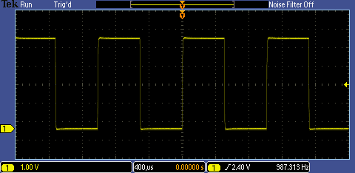
  - Turn the horizontal Scale knob until the horizontal readout indicates 10μs/div (readout is shown in the bottom center of the display.)
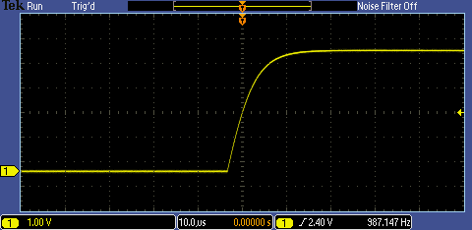
Since there are 10 divisions horizontally, a scale factor of 10 µsec/div yields a 100 µsec time window. This setting shows the actual shape of the rising edge of the square wave.
- The horizontal Position control moves the waveform and its horizontal reference or trigger point (indicated by the orange icon at the top of the display) back and forth on the display. This is used to align the displayed waveform with the horizontal divisions on the display graticule.

  - Turn the horizontal Position knob counter-clockwise to position the waveform’s falling edge at the center of the display.
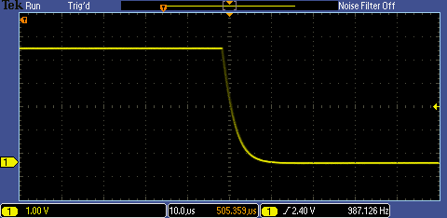

Key Points to Remember
- The horizontal scale control sets the time window displayed on the oscilloscope screen. Since there are 10 divisions horizontally, the time window is equal to:
$\text{time} \text{window} = \text{horizontal} \text{scale} \text{factor} ∗ \text{10} \text{divisions}$
- The horizontal position knob allows you to align the displayed waveform with the horizontal divisions of the display graticule or to view a different section of the displayed waveform.

Exercise
If the horizontal scale factor were set to 1 μsec/div, the displayed time window would be:

10 μsec = (1 μsec/div)x(10 divisions)

Setting the Record Length
- The following steps will investigate the relationship between the oscilloscope’s horizontal scale factor, record length and sample rate.
  - Set the horizontal scale to 100μs/div.
  - Press the Acquire front panel button. Press the Acquisition Details bottom bezel button. Notice that the sample rate is currently 125 MS/s for a record length of 125 kpoints.
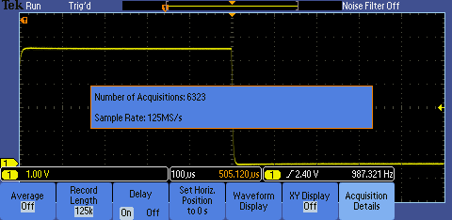
  - Press the Record Length bottom bezel button and press the 1.00M points side bezel button. This sets the record length to 1 Mpoints.

  - Press the Acquisition Details bottom bezel button again. Notice that the sample rate is now 1 GS/s. The 1 msec time window has not changed, meaning the sample rate was increased by the same ratio as the record length.
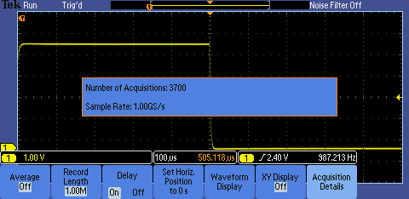

Key Points to Remember
- The sample rate of the oscilloscope is determined by the displayed time window (and therefore, the horizontal scale factor) and the selected record length.
$$\text{sample} \text{rate} = \frac{\text{record} \text{length}}{\text{time} \text{window}}$$

Exercise
With the horizontal scale factor set to 200 μsec/div and the record length set to 1 Mpoints, what is the oscilloscope’s sample rate? Verify your answer by looking at the acquisition details on the oscilloscope.
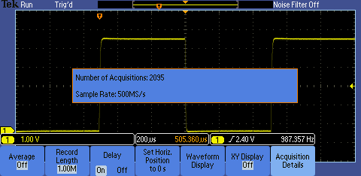
Sample rate = (1 Mpoints)/(200 μsec/div * 10 div) = 500 MS/sec

Trigger Controls

Introduction
The trigger defines when a signal is acquired and stored in memory. For a repetitive signal, a trigger is required to stabilize the display.

There is a front panel control to set the trigger level and a button to force the oscilloscope to trigger. The Trigger menu offers different trigger types and allows you to set the conditions of the trigger.

Trigger Level Control
- The following steps will explore the use of the front panel trigger level control.
  - Use the Default Setup and Autoset buttons to set the oscilloscope to a known starting point.
  - Press the Menu Off button to turn off the menus. Set up the oscilloscope to match the display shown here.
  - Adjust the vertical scale factor to 1 V/div using the front panel vertical scale knob
  - Position the waveform at the center of the display using the front panel vertical position knob
  - Set the horizontal scale factor to 10 μsec/div using the front panel horizontal scale knob
- In the default trigger setting, the oscilloscope looks for a rising edge on the channel 1 input signal. The trigger level control is used to set the voltage at which the oscilloscope triggers. The waveform is displayed with the rising edge aligned with the trigger point (indicated by the orange T icon at the top of the display). The trigger voltage level is shown by a yellow arrow on the right side of the display. In this case, the arrow is slightly above the vertical axis midpoint.
Explanation of trigger indicators on oscilloscope display:
  - Turn the Trigger Level knob until the trigger level, as indicated by the yellow arrow on the right side of the screen, is above the top of the waveform (about 5.5 V) resulting in an
un-triggered display.

Key Points to Remember
- A trigger defines when a signal is acquired and stored in memory.
- The trigger level has to be within the signal range to properly trigger the oscilloscope.
- For a repetitive signal, a trigger is necessary to obtain a stable display.

Exercise
Using the Trigger level control, move the trigger level in and out of the signal’s voltage range and note the effect this has on the displayed signal. Note how the text in the top left portion of the display (known as the trigger indicator) changes from Auto, to Trig?, to Trig’d depending on the position of the trigger voltage level. What do you think Trig?, and Trig’d mean?
Trig? indicates the oscilloscope is waiting for a trigger.
Trig’d indicates the oscilloscope is triggered.

(The Auto trigger indicator means the oscilloscope is in Auto trigger mode. This causes an acquisition to be made about once a second if no trigger event is found. This provides a display, but not a stable one, as illustrated here.)

Trigger Menu
- During the following steps, a trigger will be set up to create a stable display.
  - Press the Trigger Level knob (it doubles as a button) to force the trigger voltage setting to the 50% point of the signal. The oscilloscope display should now match the figure in the previous section.
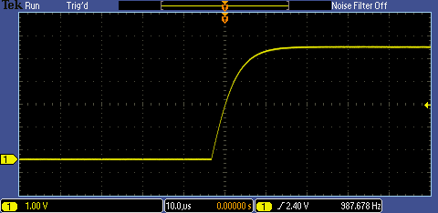
  - Change the horizontal scale factor to 100μsec to display one full cycle of the signal.
  - Press the front panel Trigger Menu button.
The Trigger Menu allows you to specify the trigger event used to capture a waveform. Available trigger types include specific pulse widths and glitches, short digital “runt” pulses, rise time, fall time and several others.
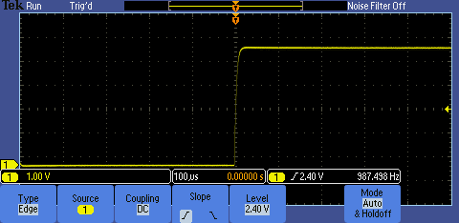
  - Press the Source bottom bezel button. The source menu allows you to select which signal to monitor for the trigger event.
  - Use the Multipurpose a control to select the channel that will be the source of the trigger. Select channels 2, 3 and 4 in sequence and note the effect this has on the triggered state of the display. When channel 1 is not selected, the display is not triggered because channels 2, 3 and 4 do not have an applied signal.
  - Use the Multipurpose a control to select channel 1 and ensure the display is triggered. Press the Menu Off front panel button.
  - Press the Slope bottom bezel button to select the falling edge of the signal as the trigger point.
The slope menu controls whether the trigger looks for a positive or negative edge on the trigger signal.
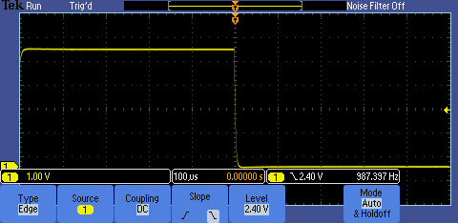
- The edge trigger is used by default. However, because the trigger is a critical element in making a measurement, there are several trigger options to pick from based on your measurement needs. Perform the following steps to see how a few of the other trigger types are used.
  - Press the Type bottom bezel button for a selection of trigger types.
  - Use the Multipurpose a knob to select Pulse Width.
  - Press the Trigger When bottom bezel button.
  - Use the Multipurpose a control to select Pulse Width =.
The Pulse Width = setting causes the oscilloscope to trigger when the pulse width is within +/-5% of the specified values.
  - Use the Multipurpose b control to select 500μs and note the oscilloscope triggers on the 500 μsec pulse. Remember this signal has a period of 1 msec with a 50% duty cycle. Thus the pulse width is 500μsec.
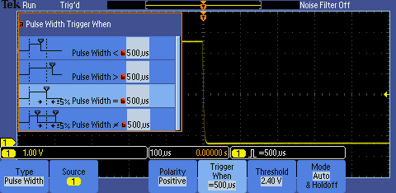
  - To return to the default Edge trigger mode, press the Type bottom bezel button and use the Multipurpose a knob to select Edge trigger. Then press the front panel Menu Off button twice to remove the menus.
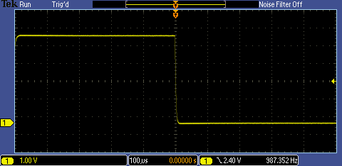

Key Points to Remember
- Pressing the trigger level knob forces the trigger level to the 50% point of the applied signal.
- The trigger menu allows you to specify the trigger event used to capture a waveform.
- Use the trigger source menu to select which input channel to monitor for the trigger event.
- Use the trigger slope control to specify which edge (rising or falling) to trigger on.
- The pulse width trigger can isolate pulses within a signal.

Exercise
In this last exercise, a pulse width trigger was used to capture a 1 kHz square wave. To trigger on all square waves that are faster than 500 Hz, how would you set up the oscilloscope’s trigger? Assume the square wave has a 50% duty cycle.

A 500 Hz square wave has a period of 2 msec. Since the duty cycle is 50%, the signal’s pulse width is 1 msec. To trigger the oscilloscope on a square wave faster than 500 Hz, I would use the “Pulse Width <” trigger type set to 1 msec. This would set up the oscilloscope to trigger when it encounters a pulse width of < 1 msec, implying a square wave faster than 500 Hz.

Oscilloscope Measurements

Introduction
A digital oscilloscope can make a variety of measurements on electrical signals, such as peak-to-peak and RMS amplitude measurements and frequency, period, and pulse width timing measurements. The oscilloscope provides several ways to make these measurements. This section will review the three most common measurement methods:
- Manual measurements
- Cursor measurements
- Automatic measurements

Manual Measurements. Manual measurements rely upon the graticule on the display and the vertical and horizontal scale settings to make measurements. A typical graticule has 8 divisions vertically and 10 divisions horizontally. For the highest accuracy, scale and position the waveform to fill the display vertically and horizontally and then visually measure the parameter in units of graticule divisions. Then multiply the number of divisions by the scale factor to get the final measurement value.

Cursor Measurements. Cursor measurements are made by manually aligning a pair of cursors to points on the waveform and then reading the measurement values from the display cursor readouts.

Automatic Measurements. Automatic measurements use algorithms stored in the oscilloscope’s firmware. These algorithms identify the appropriate waveform characteristics, make the measurements, scale the measurements, apply the appropriate units and display them on the oscilloscope.

Manual Measurements
- The following exercise will explore making manual waveform measurements.
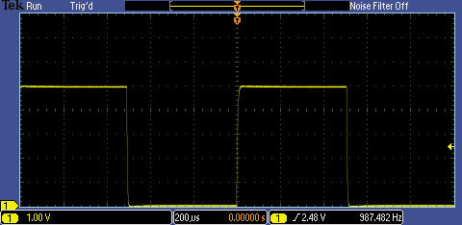
  - Reset the oscilloscope back to a known staring point and use the front- panel controls to create this display.
Normally, for greatest accuracy, the waveform is adjusted vertically to fill as much of the display as possible. For this exercise, leave the waveform as shown to the right.
  - Press the Default Setup front panel button
  - Press the Autoset front panel button
  - Adjust the vertical scale factor to 1 V/div using the front panel vertical scale knob
  - Position the waveform at the bottom of the display using the front panel vertical position knob
  - Set the horizontal scale factor to 200 μsec/div using the front panel horizontal scale knob

Exercise
- Determine the amplitude of the signal by counting the number of vertical divisions on the graticule and multiplying that by the vertical scale factor. Write the amplitude here:
Amplitude = 5 divisions x 1 V/div = 5 V

- Calculate the period of the signal by counting the number of horizontal divisions on the graticule and multiplying that by the horizontal scale factor. Write signal period here:
Period = 5 divisions x 200 μsec/div = 1 msec

- Calculate the frequency of the signal by performing the following calculation:
Frequency = 1/(signal period). Write the frequency here:
Frequency = 1/(1 msec) = 1 kHz

Cursor Measurements
- For greater measurement accuracy, the oscilloscope provides cursors that will be used in the next series of steps.
  - Press the front panel Cursors button twice to turn on all the cursors.
    - The vertical cursors measure time along the horizontal axis.
    - The horizontal cursors measure voltage along the vertical axis.
    - When the cursors are inactive, they are dotted. Solid lines indicate the cursors are active.
  - Press the Select button to cause the horizontal cursors to turn solid if they are not already. Use the Multipurpose a and b knobs to position the horizontal cursors to the top and bottom of the waveform. Write the signal amplitude from the upper right corner of the display in the Exercise section below.
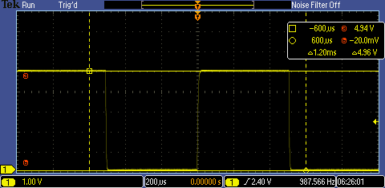
  - Press the Select button to select the vertical cursors. Notice the a and b indicators move to the timing readout and the vertical cursors go from dotted to solid.
  - Use the Multipurpose a and b button to position the cursors at the start and end of one cycle of the signal (falling edge to falling edge) and then read out the time on the display.
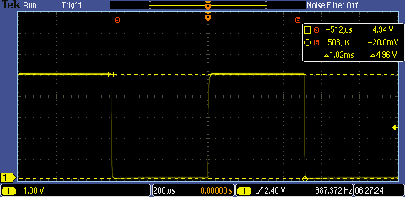
Exercise
- Write the signal amplitude here:
Signal amplitude = 4.96 V

- Write the period of the signal here:
Signal period = 1.02 msec

Automated Measurements
- The MSO/DPO2000 Series oscilloscopes offer 29 automated measurements. To make automated peak-to-peak amplitude, period and frequency measurements, the oscilloscope needs to display at least one full cycle of the waveform and have the waveform fill as much of the vertical axis as possible without the signal going off the top or the bottom of the screen. This ensures the measurement algorithms have a complete description of the waveform in memory upon which to make calculations.
The next steps will use the oscilloscope’s automated measurements to analyze the signal.
  - Press the Cursor button once to turn off the cursors.
  - Press the front panel Measure button.
  - Press the Add Measurement bottom bezel button.
  - Use the Multipurpose a knob to select Peak-to-peak and press the OK Add Measurement side bezel button.
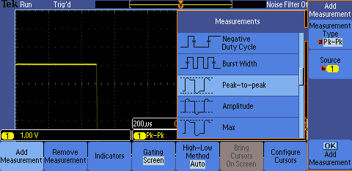
  - Use the Multipurpose a knob to select Period and press the OK Add Measurement side bezel button.
  - Use the Multipurpose a knob to select Frequency and press the OK Add Measurement side bezel button.
  - Press the Menu Off button twice. The Pk-Pk, Period and Freq automated measurements should now be displayed at the bottom of the screen.
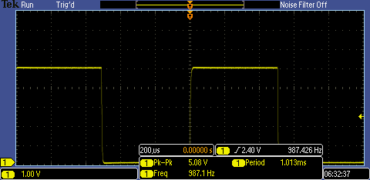
Exercise
- Write the results from the peak-to-peak and period automated measurements here.
Signal peak-to-peak amplitude = 5.08 V
Signal period =1.013 msec

- What is the % difference between your automated measurements and manual measurements? Between your automated measurements and cursor measurements?
% difference (automated vs. manual):
% diff amplitude = [(5.08 V – 5 V) / (5.08 V)] x 100% = 1.6%
% diff period = [(1.013 msec – 1 msec) / (1.013 msec)] x 100% = 1.3 %
% difference (automated vs. cursor):
% diff amplitude = [(5.08 V – 4.96 V) / (5.08 V)] x 100% = 2.4%
% diff period = [(1.013 msec – 1.02 msec) / (1.013 msec)] x 100% = -0.7 %

Key Points to Remember
- Measurements can be made manually, with cursors or automatically using firmware-based algorithms that process waveform data stored in the oscilloscope’s memory.
- Manual measurements have the lowest accuracy, cursors are typically more accurate than manual measurements and automated measurements are the most accurate of all the techniques.
- All signal elements pertaining to an automated measurement must be displayed on the oscilloscope’s screen.

Final Exercise
- The first parameter to consider when choosing an oscilloscope is:
  - Size
  - Record Length
  - Bandwidth
  - Number of Measurements
Answer: c
- Oscilloscopes usually:
  - Display amplitudes such as voltages on the vertical axis of the display.
  - Provide the most-commonly used controls on the front panel.
  - Provide multiple ways to make waveform parameter measurements.
  - All the above.
Answer: d
- A typical digital oscilloscope:
  - Conditions analog input signals with amplification.
  - Samples the input signals at a high sample rate and converts them to digital format.
  - Stores the digitized waveform data in memory and displays the waveform on the display.
  - All the above.
Answer: d
- The three primary sets of oscilloscope controls are:
  - Vertical, Measurements and Display
  - Horizontal, Autoset and Measurements
  - Vertical, Horizontal and Trigger
  - Trigger, Measurements and Cursors
Answer: c
- Oscilloscopes can make measurements with:
  - Automated measurements using firmware-based algorithms to process stored waveform data.
  - Cursor measurements.
  - Manual measurements based on the graticule of the display.
  - All the above.
Answer: d

- This final exercise will require the use of the skills and knowledge gained to this point.
- Begin by using the USB cable to connect the demonstration board to the oscilloscope’s USB port as shown in the figure to the right. | 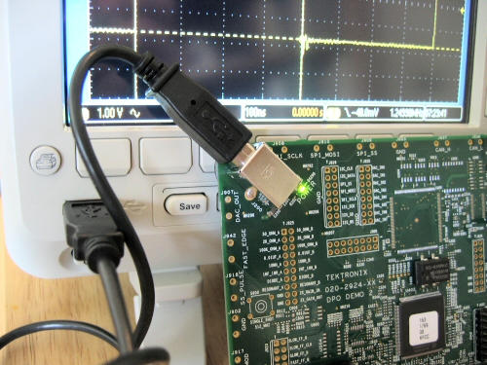
- Connect the oscilloscope probe’s alligator ground tip to the GND connector and the probe tip to the pin labeled CNT_CLK as shown in the figure to the right. Press the Default Setup button. |  | 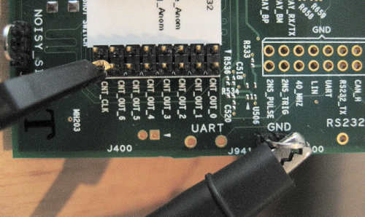
  - Set up the oscilloscope to obtain a stable display consisting of 2-4 cycles and to fill as much of the screen vertically as possible without clipping the waveform. Do Not Use Autoset!
Write your steps down here:
  - Set the horizontal scale factor to 400 nsec/div using the front panel horizontal scale knob
  - Adjust the vertical scale factor to 1 V/div using the front panel vertical scale knob
  - Position the waveform at the center of the display using the front panel vertical position knob
  - Set the trigger level to 50% by pushing in the trigger level knob. You could also set the trigger level using the level knob in the trigger section.

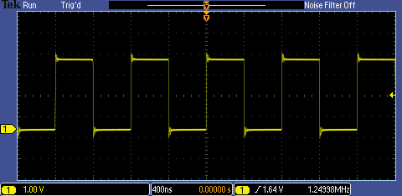
  - Using the display’s graticule, measure the following:
    - peak-to-peak voltage = 4 div x 1 V/div = 4 V
    - period of the signal = 2 div x 400 ns = 800 ns
  - Using the oscilloscope’s cursors, measure the following:
    - peak-to-peak voltage = 4.20 V
    - period of the signal = 800 ns
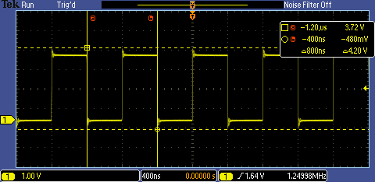
  - Using the oscilloscope’s automated measurements, measure the following:
    - peak-to-peak voltage = 4.12 V
    - period of the signal = 800 ns
    - frequency of the signal = 1.25 MHz
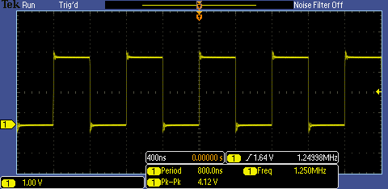

Tektronix products are covered by U.S. and foreign patents, issued and pending. Information in this publication supersedes that in all previously published material. Specification and price change privileges reserved. TEKTRONIX and TEK are registered trademarks of Tektronix, Inc. All other trade names referenced are the service marks, trademarks or registered trademarks of their respective companies.
06/09 GB/WWW 3GW-24274-0 Guide

