

Digital Debug With
Oscilloscopes
Lab Experiment

A collection of lab exercises to introduce you to digital debugging techniques with a digital oscilloscope.

Copyright Notice and Reproduction Rights

©2009 Tektronix, Inc.

This document may be reprinted, modified and distributed in whole or in part for the limited purpose of training users or prospective users of Tektronix oscilloscopes and instrumentation. Any reproduction must include a copy of this page containing this notice.

Table of Contents

Laboratory Experiment Introduction 4
Objectives 4
Equipment List 4
Methodical Approach to Digital Debug 5
Introduction 5
Four Step Approach to Digital Debug 5
Review of Digital Concepts 7
Initial Setup 10
Capturing a Pulse Stream 10
Discovering Anomalies on Digital Signals 11
Capturing Digital Anomalies 13
Searching for Anomalies with Wave Inspector 15
Analyzing Digital Signals with Automated Measurements 17
Final Exercise 20

Laboratory Experiment Introduction

Objectives
Learn a methodical approach to debugging a typical digital design with an oscilloscope:
- Discover anomalies in signals.
- Capture specific events of interest.
- Search for all events of interest using Wave Inspector automatic search.
- Analyze the signals with cursors and automated measurements.

Equipment List
- One Tektronix MSO2000 or DPO2000 Series digital oscilloscope.
- One Tektronix P2221 1X/10X passive probe.
- One Host/Device USB cable.
- One Tektronix 878-0456-xx demonstration board.

Methodical Approach to Digital Debug

Introduction
As digital designs become more complex, engineers need tools to help find and diagnose problems quickly. Oscilloscopes are used in the design and debug process to discover problems quickly, capture events of interest, search for and gain insight into those events of interest, and then analyze the circuit behavior and solve the problem.

Four Step Approach to Digital Debug

Discover
To solve a problem, you must first be able to find and visualize the problem. As you have learned in previous labs, the first step to visualizing signals is accurately getting those signals into the instrument. To do this, you need to use the right probes to maintain high signal fidelity and minimize any loading effects on the circuit.

Then you need a lively display of the signals so you can visualize how the signals are changing over time. Because an oscilloscope displays “snapshots” of the signals, you need an oscilloscope with a fast waveform capture rate. The result is the ability to see glitches or other infrequently occurring transients within seconds, revealing the true nature of faults.

Seeing the problem is only half of the solution. You also need to understand how frequently the signal anomaly is occurring relative to the normal signals. This is where a DPO (Digital Phosphor Oscilloscope) with an intensity-graded display of waveforms shows a “history” of a signal’s activity by intensifying areas of the signal that occur more frequently. This provides a visual display of just how often anomalies are occurring relative to other signals.

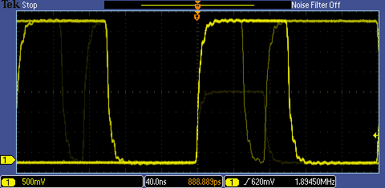
Figure 1: Intensity-graded display showing infrequent transients

Capture
Once you have an event of interest, you want to capture that event in memory and better understand the underlying causes of the event. Oscilloscopes use specialized triggers to narrow your focus to the events of interest by capturing specific digital events such as runts, glitches, pulse widths, setup and hold violations, and serial and parallel patterns.

You will often want to view signals before and after the trigger event so you can understand the context around the event of interest or to capture many events of interest for further analysis. Or you may want to acquire only a few events of interest but retain enough sample point resolution to be able to zoom in on fine signal details. In either case, you will often want to use long record lengths to capture long time periods with high timing resolution. Record length, one of the key specifications of an oscilloscope, is the number of samples it can digitize and store in a single acquisition. The longer the record length, the longer the time window you can capture with high resolution (high sample rate).

In complex designs, you may need to capture several analog, serial, and parallel digital signals to understand the circuit conditions that are causing the trigger event. Mixed Signal Oscilloscopes (MSOs) are ideally suited to these applications. MSOs have unique capabilities for capturing digital signals, including Threshold controls which allow you to specify what voltage represents a digital ‘1’ and which represents a digital ‘0’. Some MSOs can automatically detect multiple transitions on digital edges.

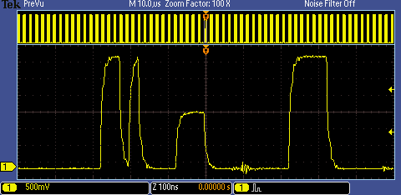
Figure 2: Long waveform record acquisition with a runt trigger event

Search
Finding one specific event in a long waveform record can be challenging. The MSO/DPO2000 oscilloscope shows 480 points of waveform data at one time on its display. A 1 million point record length represents over 2000 screens worth of data! Waveform navigation and search tools, such as Wave Inspector® on the MSO/DPO Series, simplify finding an event of interest. Wave Inspector offers dedicated front panel controls for panning and zooming of records for manual navigation and inspection of long data records. You can add your own marks to any location you want to reference later for further investigation. In addition, the automated search will search through millions of acquired data points looking for your specified event, including analog, digital, and serial bus data. Along the way it will automatically mark every occurrence of the event of interest so you can quickly move between matching events.

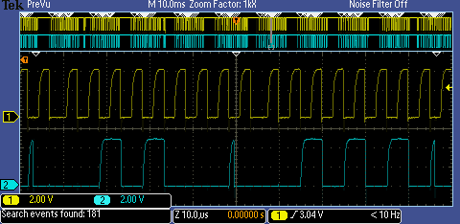
Figure 3: Wave Inspector automatic search for glitches.
All glitches have been marked with a white triangle.

Analyze
Once you have discovered, captured, and located events of interest, you need to analyze the signals. As you’ve seen in previous labs, cursor measurements, automated measurements, and waveform math including FFT are all useful tools for analyzing signals.

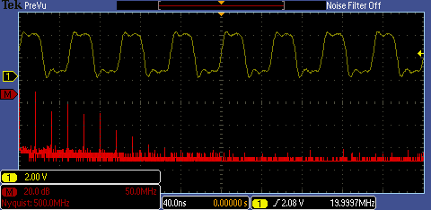
Figure 4: FFT plot of a pulse stream.

Key Points to Remember
- There are four major steps to debugging most circuit problems:
  - Discover the problem. This may require seeing elusive events such as glitches, runts or other transients. Digital Phosphor Oscilloscopes provide a visual display of just how often anomalies are occurring relative to other signals to help spot these events.
  - Capture the event of interest into the oscilloscope’s memory. This will allow you to analyze the event to better understand underlying causes. Oscilloscope triggers allow you to specify a specific event for the oscilloscope to capture. Record length determines how much time you capture.
  - Search and find the event. Long record lengths can be difficult to navigate; oscilloscope tools like automated search make it easier to find one specific event.
  - Analyze the event to identify root cause. Waveform analysis tools, such as automated measurements, statistics, and cursors help you understand the characteristics of an event to diagnose the problem.

Review of Digital Concepts
A digital signal is a signal used to communicate a specific digital value. The simplest and most common example is a binary signal, where any voltage below a specific value called a “threshold” represents a digital “low” or ‘0’ and any voltage above the threshold represents a digital “high” or ‘1’. This simple decision process is used on the digital channels of an MSO. Therefore, one of the first steps in capturing a digital signal with an MSO is to set the threshold value appropriately.
Figure 5: Logic Threshold
As long as the signals are relatively large and transition quickly between high and low voltages, this simple process works well. However, when the voltage is right at the threshold level, the digital state is indeterminate, and can cause the circuit to behave unpredictably.

To increase the reliability of this high/low decision process, many circuits use two threshold values. In this case, a digital ‘1’ must be higher than the upper threshold level and a digital ‘0’ must be lower than the lower threshold level. Any signal between the threshold levels is indeterminate. Oscilloscopes use this dual-threshold technique for certain triggering modes such as runt triggering. In the following lab, one of the digital faults you will see is a “runt” pulse, which is a short pulse that crosses the lower threshold but is not high enough to cross the upper threshold and be interpreted as a ‘1’.
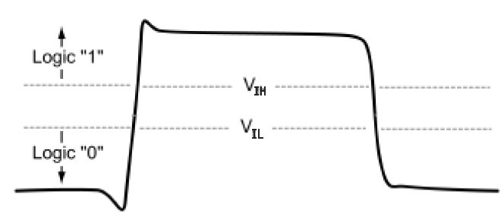
Figure 6: Dual Threshold Logic
In many digital designs, the binary digits or “bits” are used to represent a specific digital state, such as which switch was pressed or which light should be turned on. “Synchronous” systems use a clock to define the exact times when the bits are valid. For synchronous or clocked circuits to work correctly, the bits must be stable for a minimum amount of time (called the “setup time”) before the clock edge occurs and must remain stable for a minimum amount of time (called the “hold time”) after the clock edge occurs. If the setup or hold time specification is violated, the circuit will behave unpredictably.
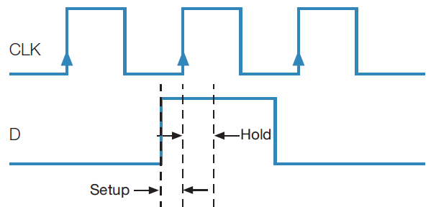
Figure 7: Setup and Hold Time

Key Points to Remember
- With a binary signal, any voltage below a specific value called a threshold represents a digital “low” or ‘0’ and any voltage above the threshold represents a digital “high” or ‘1’.
- When the voltage is right at the threshold level, the digital state is indeterminate, and can cause the circuit to behave unpredictably.
- With dual-threshold logic, a digital ‘1’ must be higher than the defined upper threshold level and a digital ‘0’ must be lower than the defined lower threshold level. Any signal between the threshold levels is indeterminate.
- For synchronous or clocked circuits to work correctly, the setup and hold time specifications must be met. Otherwise, the circuit will behave unpredictably.

Exercise
- A signal that has an amplitude between threshold levels is most correctly known as a _________________.
  - runt
  - glitch
  - pulse
  - distortion
- __________ is the minimum amount of time bits must be stable before the clock edge occurs.
  - Hold Time
  - Settling Time
  - Over Ring Time
  - Setup Time

Initial Setup

Capturing a Pulse Stream
- To setup the equipment for the following lab exercises, perform the following steps.
  - Power up the oscilloscope by pressing the power switch on the lower left corner of the instrument.
  - Press the front panel Default Setup button to set the oscilloscope to a known state.
  - Connect the P2221 1X/10X passive probe to the channel 1 input.
  - Make sure the slider switches on both probes are set to 10X.
- The Tektronix demonstration board has a number of digital signals which you can use for these labs. Let’s start with a digital signal with frequent anomalies, labeled FREQ_ANOM.
  - Attach the channel 1 probe ground lead to the GND connector on the demo board and the probe tip to the FREQ_ANOM signal pin.
  - Plug the USB cable into the USB host port on the front of the MSO/DPO2000 Series oscilloscope and the USB device port on the demo board.
  - Verify the demo board’s green POWER LED is lit.
  - Set the horizontal Scale to 200 ns/div.
  - Using the front panel Trigger Level control, set the trigger level to about 2 V.
  - Press the front panel Trigger Single button.
  - 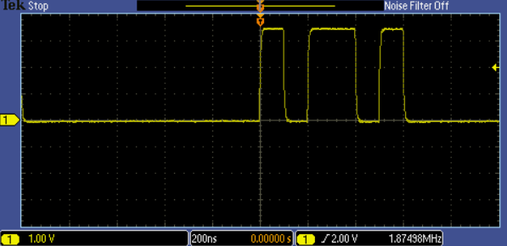Press the Menu Off button to remove the menus. The display should look like this.

Exercise
- Using the figure shown in step 2-g, what is the binary value of the digital signal at t = 300 ns, if the threshold for a logic high is +2 V?

Discovering Anomalies on Digital Signals
- If you really want to know if a digital signal is behaving as expected, you need to monitor the signal with a lively display (a high waveform capture rate) to see any infrequent events. The following steps will demonstrate using an oscilloscope to discover anomalies on a digital signal.
  - Press the front panel Single button several times while watching the display. Did you see any signals that did not have similar high and low values? Did you see any narrow pulses? Or did the signal look OK?
  - Press the front panel Run/Stop button. Notice the Run indicator appears in the upper left corner of the display. The oscilloscope is now capturing waveform after waveform and overlaying them on the screen.
- When you look at the same signal with hundreds or thousands of waveforms overlaid, you should see something like this:
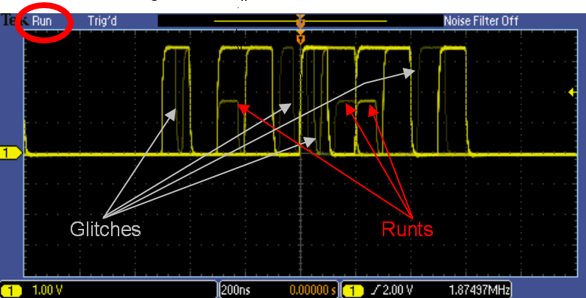
  - Notice that there are several different anomalies on this signal, including some narrow pulses or “glitches” and several reduced-amplitude pulses of “runts”.
- Also, notice that the displayed brightness or intensity of some of the anomalies is much less than the desired digital signal. This variation in brightness or “intensity-grading” indicates the relative frequency of occurrence of the different signals. The brighter waveforms are occurring more often, while the dim signals are occurring very infrequently. The intensity-graded display allows you to easily see if your signal has anomalies and if so, what they look like. It’s important to understand the type of anomalies in the signal to be able to set up the oscilloscope to trigger on those anomalies for further analysis.
  - If you would like to adjust the relative brightness or intensity of the waveforms on the display, press the front panel Intensity button, adjust the intensity with the multipurpose a control, and press the front panel Intensity button again.
- Now that you have discovered these problems, you can easily capture them using specialized digital debug tools on the oscilloscope such as pulse width and glitch triggers.

Key Points to Remember
- To check if a digital signal is behaving as expected, you can monitor the signal with a lively display (a high waveform capture rate) to see any infrequent events.
- With an intensity-graded display, waveform after waveform is overlaid. The variation in brightness or “intensity-grading” indicates the relative frequency of occurrence of the different signals. The brighter waveforms are occurring more often, while the dim signals are occurring very infrequently.
- An intensity-graded display allows you to see the size and shape of anomalies in your signal. Understanding the type of anomalies in the signal allows you to set up the oscilloscope to trigger on them.

Exercise
- On an intensity-graded display, faint waveforms are those that ___________________ brighter waveforms.
  - occur as frequently as
  - occur less frequently than
  - occur more frequently than
  - have higher frequency content than
- Which of the following best describes a glitch pulse:
  - Glitches exceed the maximum signal voltage level.
  - Glitches are negative voltage pulses.
  - A glitch pulse has less than the recommend pulse duration period.
  - A glitch pulse duration exceeds the recommend pulse period.

Capturing Digital Anomalies
- First, let’s capture and examine one of the narrow pulses you can see in the signal.
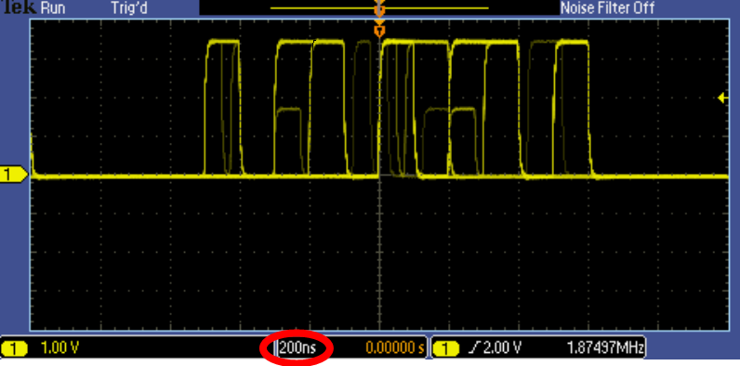
- The readout at the bottom of the display indicates that the horizontal scale is set to 200 ns/div. The narrow pulses appear to be less than about a quarter of a division wide, so let’s use pulse width triggers to capture all pulses that are narrower than about
50 nsec.
  - Press the front panel Trigger Menu button to display the trigger menu.
  - Press the Type bottom bezel button and use the multipurpose a control to select the Pulse Width trigger type.
  - Press the Trigger When bottom bezel button and use the multipurpose b control to set the Pulse Width < value to 50.0 ns.
  - Press the front panel Menu Off button to remove the side menu.
  - Press the front panel Single button.
- With the positive pulse width trigger, you can easily capture each of the narrow positive pulses in the signal, shown in the center of the display next to the orange trigger ‘T’ icon. Notice that, with pulse width triggering, a single threshold value (2 V) is used, and the pulse width is measured at that voltage.
- Now, let’s capture and examine the low-amplitude “runt” pulses you can see in the signal. Remember that the amplitude of a runt pulse exceeds the lower threshold, but does not exceed the upper threshold.
  - Press the Type bottom bezel button and use the multipurpose a control to select the Runt trigger type.
- The readout at the bottom of the display indicates that the vertical scale is set to 1.0 V/div. The runt pulses appear to be more than one division tall, but less than two, so let’s set the thresholds at 1V and 2V.
  - Press the Thresholds bottom bezel button and use the multipurpose a control to set the High Threshold to 2.00 V and use the multipurpose b control to set the Low Thresholds to 1.00 V.
  - Press the Menu Off button to remove the side menu.
  - Press the front panel Run/Stop button.
- With the runt trigger, you can easily capture each of the positive runt pulses in the signal, shown in the center of the display next to the orange trigger ‘T’ icon.
- In each of these previous cases, you used the oscilloscope’s trigger to capture at least one known event in each acquisition.

Key Points to Remember
- To capture and examine glitches in a signal, you can use the positive pulse width trigger. The oscilloscope will trigger when it encounters a glitch, capturing the signal for further analysis.
- Pulse width triggering uses a single threshold value. The pulse width is measured at that voltage.
- To capture and examine low-amplitude “runt” pulses, you can use the runt trigger. The oscilloscope will trigger when it encounters a runt.
- Runt triggering looks for a pulse that crosses the defined Low Threshold but doesn’t cross the defined High Threshold.

Exercise
- Describe the type of trigger and trigger parameters (including polarity, threshold value(s) and other settings) you would use to capture the anomaly seen on the signal below.
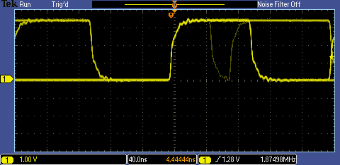

Searching for Anomalies with Wave Inspector
- In the previous section, the oscilloscope’s trigger was used to capture at least one event (glitch or runt pulse) in each acquisition. But what do you do if you don’t know what event to capture? How do you know how many times a given event occurred? For answers to these and other questions, you can use Wave Inspector zoom, navigation, and search.
  - Using the front panel Horizontal Scale control, set the horizontal scale to 100µs/div.
  - Press the front panel Single button. At this horizontal scale setting, the acquired waveform looks about like this.
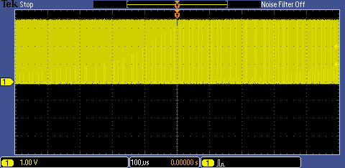
- It is very difficult to see much signal detail in this display. If we graphically zoom the waveform, the details become much more visible.
  - Turn the inner Wave Inspector control clockwise to turn on zoom. Adjust the zoom scale to clearly display the runt pulse at the trigger point.
  - Turn the outer, spring-loaded Wave Inspector control to move the zoom window to the left or right. The harder you turn the control, the faster the panning.
  - Notice that the entire waveform is shown at the top of the screen, while the zoomed region indicated with the white brackets is displayed at the bottom of the screen.
  - Press the Wave Inspector play/pause button to automatically pan through the acquisition. You can use the outer Wave Inspector control to change the speed and direction of the automatic panning. Can you find another runt pulse anywhere in this acquisition?
  - When you are done manually searching for another runt pulse, press the play / pause button to turn off the automatic panning.
- Wave Inspector also provides the ability to automatically find and mark characteristics of interest on a waveform. These automatic marks are drawn as white triangles at the top of the display.
  - Press the front panel Search button.
  - Press the Search bottom bezel button and the Search side bezel button to turn on automatic searching.
  - Press the Copy Trigger Settings to Search side bezel button. This copies your runt trigger setup into the search engine.
- 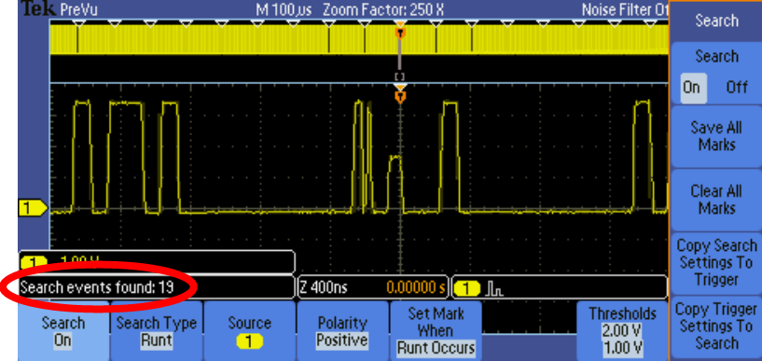After a second or two, notice the white triangles at the top of the display. In the example shown at the left, the search engine automatically found 19 search events in the acquisition.
  - To jump back and forth between these marks, press the front panel ← and → arrow buttons.
  - When you are done using the search features, press the Search side bezel button to turn off automatic searching.

Key Points to Remember
- With Wave Inspector on the MSO/DPO2000 Series, the entire waveform is shown at the top of the screen, while the zoomed region indicated with the white brackets is displayed at the bottom of the screen.
- Use the Wave Inspector controls to manually pan and zoom through the acquired waveform.
- Use the Wave Inspector play/pause controls to automatically pan through the waveform.
- Wave Inspector provides the ability to quickly and automatically find and mark characteristics of interest on a waveform. These marks are drawn as white triangles at the top of the display.

Exercise
- Using the same waveform acquisition, search for glitches less than 40 ns wide using Wave Inspector’s automatic search. How many search events were found?

Analyzing Digital Signals with Automated Measurements
- The MSO/DPO2000 Series cursors and automated measurements can be used to make measurements on your digital signals.
  - Press the Wave Inspector Zoom button or turn the inner control fully counter-clockwise to turn off zoom. Press the front panel Menu Off button until all menus are turned off.
  - Set the horizontal Scale to 200 ns/div.
  - Press the front panel Run/Stop button.
  - Press the front panel Cursors button once to turn on vertical bar cursors.
- The cursors may be initially be off screen such that you do not see them but, as shown in the following figure, you will see the readouts in the upper right corner of the display.
- 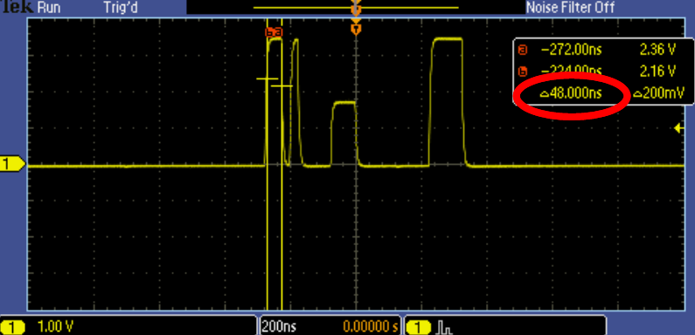You can use the Cursors to manually measure many parameters of the waveform. For example, the vertical bar cursors can easily measure the width of a pulse, shown as about
48 nsec in the cursor readout in the upper right corner of the display.
  - Using the multipurpose a control, position the a cursor on the left edge of the first pulse on the display.
  - Using the multipurpose b control, position the b cursor on the right edge of the first pulse on the display for a display similar to the previous figure.
- 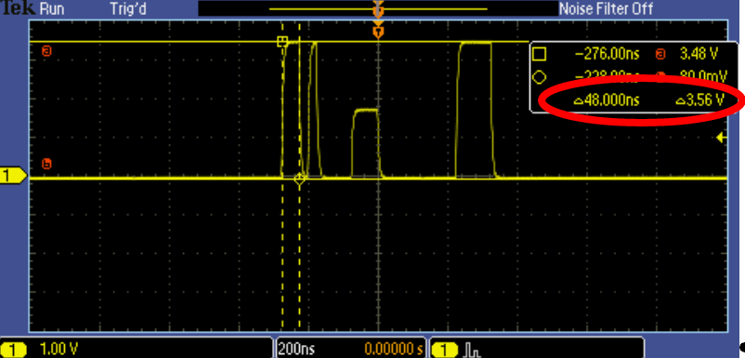You can also use screen-based cursors to measure the amplitude of a pulse. Here, the pulse width is again
about 48 nsec and the amplitude is about 3.56 V.
  - Press the front panel Cursors button one more time to turn on screen-based cursors.
  - Using the multipurpose a control, position the a cursor on the left edge of the first pulse on the display.
  - Using the multipurpose b control, position the b cursor on the right edge of the first pulse on the display.
  - Press the front panel Select button until the horizontal cursors become solid lines.
  - Using the multipurpose a control, position the a cursor on the tops of the digital pulses on the display.
  - Using the multipurpose b control, position the b cursor on the bottoms of the digital pulses on the display
  - Press the front panel Cursors button once to turn off cursors.
- Cursors provide a simple way to manually measure basic amplitude and timing parameters of digital signals. However, there are many times where automated measurements could make more measurements more quickly. Let’s start by using the automated measurements to make the same measurements you just did with the cursors.
  - Press the front panel Measure button.
  - Press the Add Measurement bottom bezel button.
  - Using the multipurpose a control, select the Positive Pulse Width measurement from the list and press the OK Add Measurement side bezel button.
  - Using the multipurpose a control, select the Amplitude measurement from the list and press the OK Add Measurement side bezel button.
  - Press the front panel Menu Off button once to remove the side menu.
  - After turning on the pulse width and amplitude measurements, we see the measurement readouts near the bottom of the display.
- If you want to focus the measurements on a specific portion of the waveform, such as the runt pulse, you can use the cursors to “gate” the measurements.
  - Press the Gating bottom bezel button.
  - Press the Between Cursors side bezel button.
  - Using the multipurpose a control, move the a cursor slightly to the left of the runt pulse.
  - Using the multipurpose b control, move the b cursor slightly to the right of the runt pulse.
  - 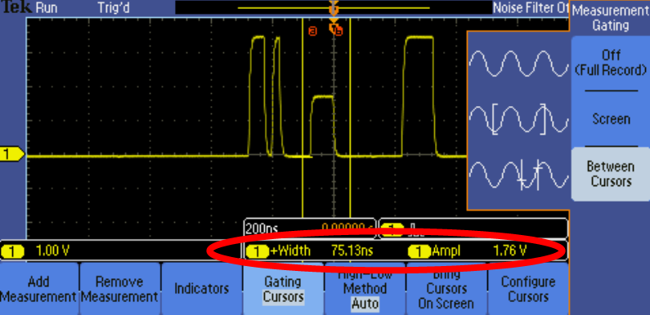Notice that the measurements are now focused on the runt pulse.

Key Points to Remember
- Cursors can measure many parameters of a waveform, including pulse width and amplitude.
- Cursors provide a simple way to manually measure basic amplitude and timing parameters of digital signals. However, there are many times where automated measurements could make more measurements more quickly.
- To focus the measurements on a specific portion of the waveform use the cursors to “gate” the measurements.

Exercise
- Using the same waveform acquisition, measure the pulse width and amplitude of the glitch pulse (the narrowest pulse on screen) using cursors and automated measurements with gating.
  - Write your results using cursors.

  - Write your results using automated measurements with gating.

Final Exercise
- Waveform capture rate is important for which stage of the digital debug process:
  - discover
  - capture
  - search
  - analyze
- To increase the reliability of correctly determining if a digital signal is a logic high or low at a specific point in time, many circuits use _______ threshold values.
      - one
  - two
  - synchronous
  - tri-State
- A runt pulse is best defined as:
  - exceeds the upper defined threshold of the digital signal, but not the lower defined threshold
  - a narrow pulse
  - exceeds the lower defined threshold of the digital signal, but not the upper defined threshold
  - exceeds the maximum allowable amplitude.
- On an intensity-graded display, a ___________________ waveform indicates a signal event that occurs more frequently than a dim waveform.
  - faint
  - bright
  - white
  - red
- The front panel Wave Inspector controls allow you to ___________________.
  - manually pan and zoom through a long waveform acquisition.
  - automatically search through a waveform for a specific event.
  - automatically pan through a waveform.
  - all of the above.

- The final exercise will require the use of the skills and knowledge gained to this point.
  - Connect the oscilloscope probe tip to the pin labeled Rare_Anom, located next to the Freq_Anom pin used in the previous exercises. Press the Default Setup button.
  - Adjust the horizontal scale factor until you can easily see the details of the pulse stream.
  - The following screen shot was taken after monitoring this signal for awhile.

  - Based on the screen shot in step c, set up the oscilloscope’s trigger to capture the anomaly. Write down your trigger type and trigger parameters. (Hint: Review your answer to Exercise #1 in the “Capturing Digital Anomalies” section.)

  - Set the horizontal scale factor to 200 ns/div. Press the Single button. Measure the pulse width and amplitude of all pulses on your display. Write the results here.

Tektronix products are covered by U.S. and foreign patents, issued and pending. Information in this publication supersedes that in all previously published material. Specification and price change privileges reserved. TEKTRONIX and TEK are registered trademarks of Tektronix, Inc. All other trade names referenced are the service marks, trademarks or registered trademarks of their respective companies.
06/09 GB/WWW 3GW-24324-0

