

Introduction to
Oscilloscope Probes
Instructor’s Guide

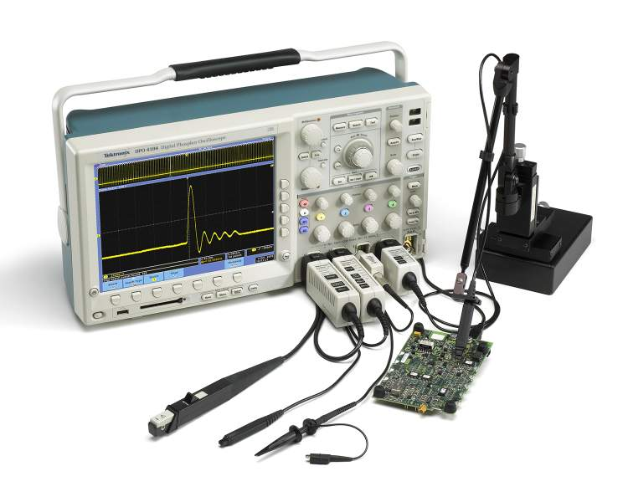
A collection of lab exercises to introduce you to oscilloscope probes, including important considerations for good signal fidelity.

Copyright Notice and Reproduction Rights

©2009 Tektronix, Inc.

This document may be reprinted, modified and distributed in whole or in part for the limited purpose of training users or prospective users of Tektronix oscilloscopes and instrumentation. Any reproduction must include a copy of this page containing this notice.

Table of Contents

Laboratory Experiment Instructor’s Guide Introduction 4
Objectives 4
Laboratory Experiment Introduction 4
Objectives 4
Equipment List 4
Overview of Oscilloscope Probes 5
Introduction 5
Performance Terms and Considerations 8
Probe Loading 10
Impact of Input Resistance 11
Impact of Input Capacitance 11
Impact Probe Inductance 12
Noise Immunity 13
Different Types of Probes 14
Passive Probes 14
Active Probes 16
Differential Probes 18
Current Probes 19
Using a Passive Probe 21
Probe Compensation Adjustment 21
Different Probing Methods 23
Final Exercise 25

Laboratory Experiment Instructor’s Guide Introduction

Objectives
- The purpose of this Instructor’s Guide is to:
  - Expand the training steps with additional oscilloscope screen and front panel images to assist students who may have questions.
  - Provide answers for each exercise.
- Instructor’s notes are in bold blue text.

Laboratory Experiment Introduction

Objectives
- Understand the basic characteristics of an oscilloscope probe.
- Describe the different types of probes and their uses.
- Learn how to connect probes to various test points in a circuit.
- Learn how probes can affect the quality of electronic measurements.

Equipment List
- One Tektronix MSO2000 or DPO2000 Series digital oscilloscope.
- Two Tektronix P2221 1X/10X passive probes.
- One Host/Device USB Cable.
- One Tektronix 878-0456-xx demonstration board.

Overview of Oscilloscope Probes

Introduction
Oscilloscope probes provide a physical and electrical connection between a signal source and an oscilloscope. Most probes consist of a probe head, a meter or two of flexible cable, and a connector which fits on the oscilloscope input.

The probe head allows you to hold the probe while you connect the probe tip to the test point. Often, this probe tip has a spring-loaded hook that allows you to attach the probe to the test point. The probe head also contains a “ground” connection, which provides the reference point for voltage measurements. (Remember that voltage measurements are always made relative to a reference point.) For many probes, this probe ground is a black wire with an alligator clip for easy connection to ground test points.
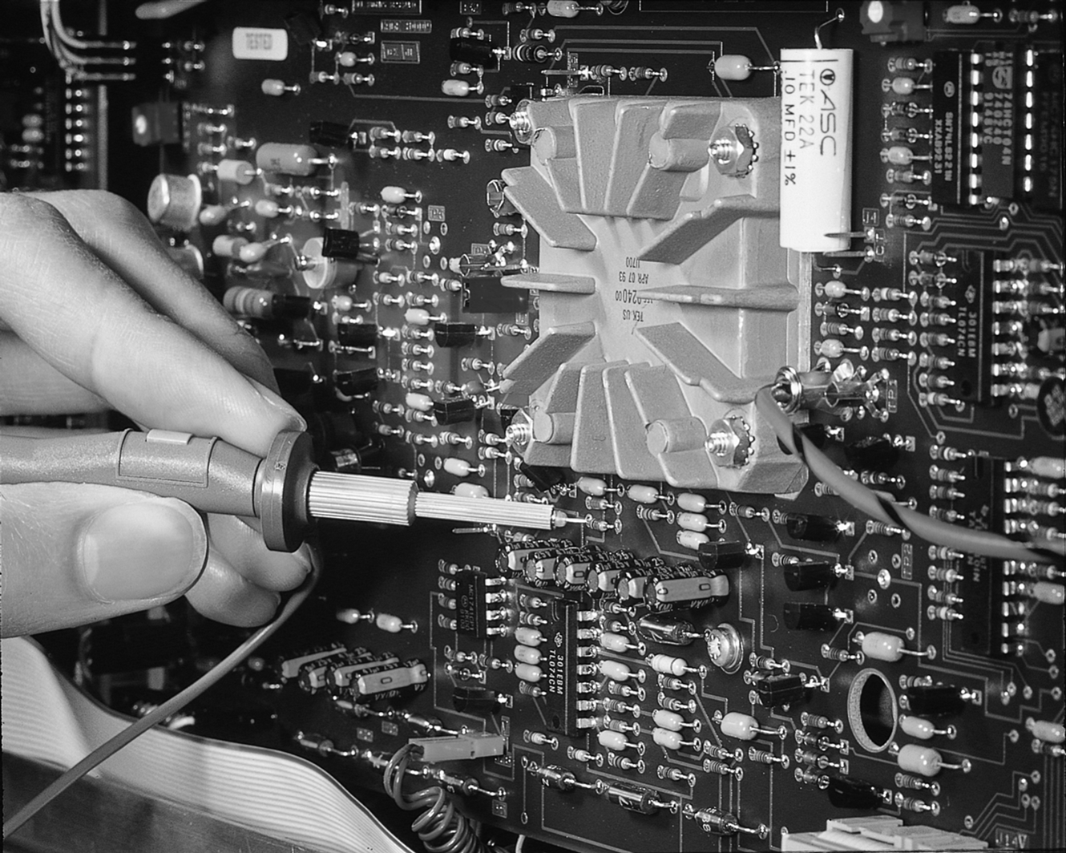
Figure 1: Probing a circuit.

Connecting a probe to a circuit can affect the operation of the circuit, and an oscilloscope can only display and measure the signal that the probe delivers to the oscilloscope input. The probe must have minimum impact on the probed circuit and it must maintain adequate signal fidelity for the desired measurements, or the result can be wrong or misleading.

Connection Ease and Convenience
The ideal probe would allow you to make the physical connection with both ease and convenience. For miniaturized circuitry, such as high-density surface mount technology (SMT), connection ease and convenience are promoted through subminiature probe heads and various probe-tip adapters. For applications such as industrial power circuitry where high voltages and larger gauge wires are common, physically larger probes with greater margins of safety are required. To make current measurements, a clamp-on current probe is required. From these few examples of physical connection, it’s clear that there is no single ideal probe size or configuration for all applications. Because of this, various probe sizes and configurations have been designed to meet the physical connection requirements of various applications.
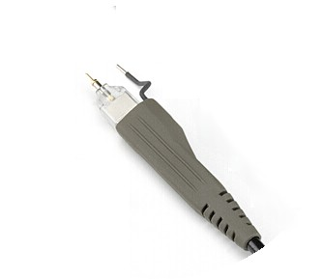  Figure 2: Subminiature probe head. | 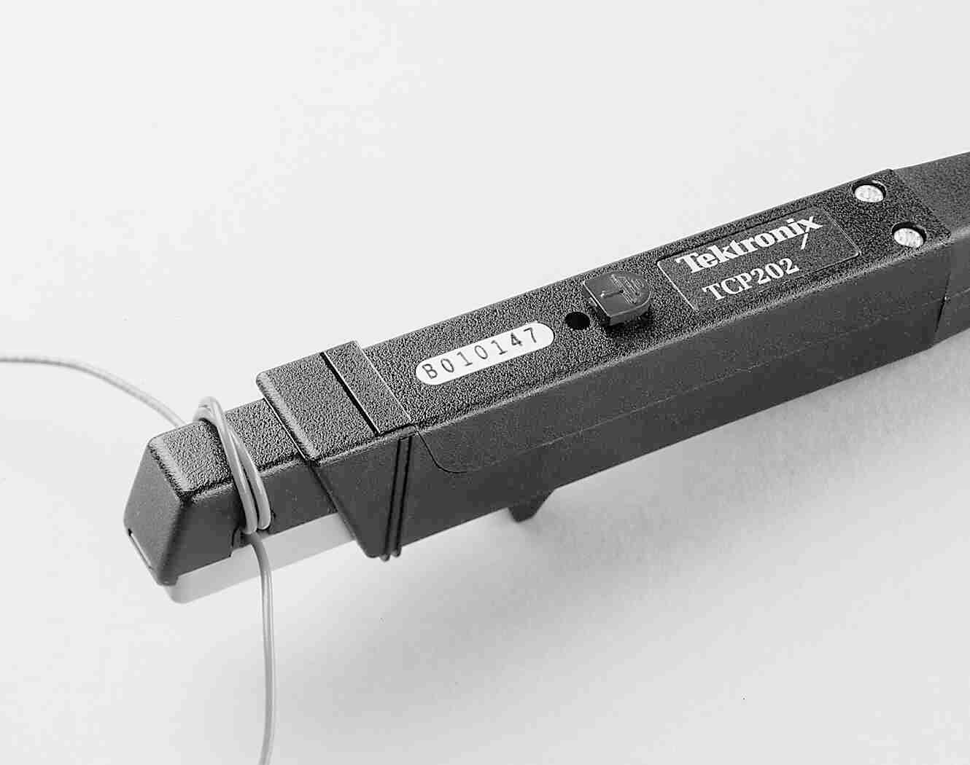  Figure 3: Clamp-on current probe.
Most probes are packaged with standard accessories. These accessories usually include a ground lead clip that you can attach to a ground signal source, a compensation adjustment tool, and one or more probe tip accessories to help connect the probe to test points.
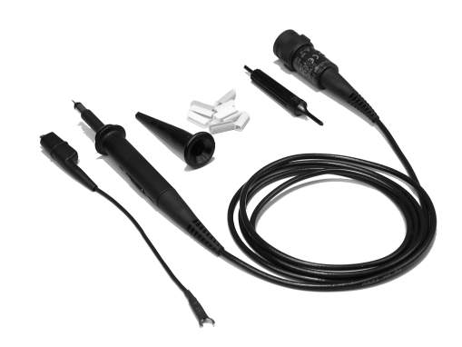
Figure 4: Typical passive probe with standard accessories.

Signal Fidelity
The ideal probe would transmit any signal from probe tip to oscilloscope input with absolute signal fidelity, meaning the signal at the oscilloscope input would be identical to the original signal at the probe tip. For absolute fidelity, the probe circuitry from tip to oscilloscope input must have zero attenuation, infinite bandwidth, and linear phase across all frequencies. Unfortunately, the ideal probe cannot be realized. The next section will discuss key performance considerations of real probes.

Key Points to Remember
- Probes provide a physical and electrical connection between the oscilloscope and the test point.
- Connecting a probe to a circuit affects the operation of the circuit.
- There are different probe sizes and configurations to meet the physical connection requirements of different applications.
- With an ideal probe, the signal at the oscilloscope input would exactly match the signal at the test point.

Exercise
- The oscilloscope probe “ground connection” provides the reference point for voltage measurements.
  - True
  - False
Answer: a
- Which of the following are desirable oscilloscope probe attributes? (Circle all that apply.)
  - Has minimum impact on the signal of interest.
  - Easy to connect to the device-under-test.
  - Always small and compact.
  - The signal at the oscilloscope is identical to the signal at the probe tip.
Answer: a, b, d

Performance Terms and Considerations

Attenuation
Attenuation is the ratio of the probe’s input signal amplitude to the output signal amplitude, usually measured at DC. Many probes are called “10X” probes, meaning that the signal applied to the oscilloscope is 1/10th of the actual input signal amplitude. It is therefore important that the oscilloscope know the probe’s attenuation and account for it in its measurements.

Bandwidth
Real probes have finite bandwidth. Bandwidth is the frequency at which the displayed amplitude of a sine wave is decreased by 3 dB or about 30%.

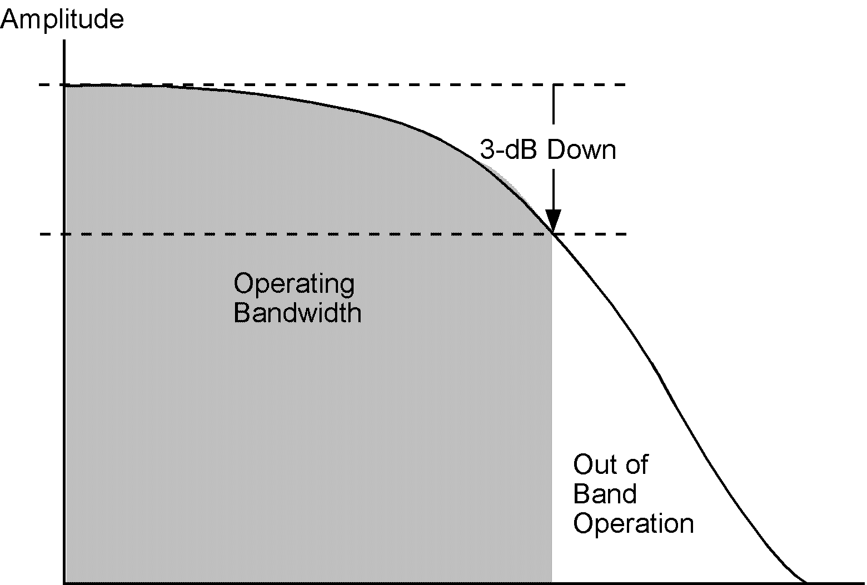
Figure 5: At frequencies beyond the 3 dB point, signal amplitudes become overly attenuated and measurement results may be unpredictable.
To ensure a sine wave amplitude error of not more than 3%, the bandwidth of the oscilloscope and probe combination should be at least five times that of the circuit being tested. This is sometimes referred to as the “five times rule”.
$\begin{aligned}\text{oscilloscope} \text{bandwidth} ≥ 5^{\text{th}} \text{harmonic} \text{of} \text{signal} \\ \\ \text{probe} \text{bandwidth} ≥ \text{oscilloscope} \text{bandwidth}\end{aligned}$

Example: If the signal of interest is 100 MHz, the oscilloscope bandwidth and probe bandwidth should both be greater than 500 MHz.

Rise Time
Bandwidth and rise- or fall-time have an inverse relationship. The rise time of the measurement system (probe and oscilloscope combination) should be less than one fifth of the rise- or fall-time of the measured signal – another “five times rule”. This should ensure an error of no more than 3% in the measured rise- or fall-time.
$\text{measurement} \text{system} \text{rise} \text{time} ≤ \frac{\text{signal} \text{rise} \text{time}}{5}$
$$\text{measurement} \text{system} \text{rise} \text{time} = \sqrt{{\left(\text{oscilloscope} \text{rise} \text{time}\right)}^{2} + {\left(\text{probe} \text{rise} \text{time}\right)}^{2}}$$
Example: If the signal of interest has a rise time of 50 nsec, then the measurement system rise time should be faster than 10 nsec. If the oscilloscope has a rise time of 2 nsec, then the probe rise time should be faster than 9.8 nsec.

Linear Phase
Bandwidth limitations also affect the shape of signals by delaying different frequency components by different amounts of time. These variations cause distortions of complex signals, especially pulses.

Key Points to Remember
- Attenuation is the ratio of the probe’s input signal amplitude to the output signal amplitude.
- The bandwidth of both the oscilloscope and probe should be at least five times that of the circuit being tested to ensure a sine wave amplitude error of not more than 3%.
- The rise time of the measurement system should be less than one fifth of the rise- or fall-time of the measured signal to ensure an error of no more than 3% in the measured result.
- Bandwidth limitations also affect the shape of signals by delaying different frequency components by different amounts of time.

Exercise
- If you need to measure a 25 MHz sine wave, what is the minimum bandwidth probe and oscilloscope you should use?
Based on the “five times rule” for bandwidth:
minimum bandwidth = 5 x 25 MHz = 125 MHz

- If you measure a +5 V signal with a 10X probe, what will the signal amplitude be at the oscilloscope input?
signal amplitude = +5 V / 10 = +0.5 V

Probe Loading
Probe loading is a measure of how the probe affects the device-under-test (DUT). The DUT can be modeled as a signal source (E_{s}) with input resistance (R_{i}) and with a load (R_{L}) connected. The probe can be modeled as a resistor (R_{p}) and a capacitor (C_{p}).

Figure 6: Equivalent circuit diagram of DUT with probe connected.
To simplify further analysis, the Thevenin equivalent of the DUT can be used in the circuit diagram.

Figure 7: Simplified circuit diagram using Thevenin equivalent of DUT.

An ideal probe has infinite impedance so it doesn’t draw any signal current from the device. If the probe does not load the device then it will not change the operation of the circuitry behind the test point, nor will it change the signal seen at the test point. In practice, a probe with zero loading cannot be achieved. The goal, however, should always be to minimize the amount of loading through appropriate probe selection.

The value of the device impedance influences the effect of probe loading. For example, with low device impedance, a high-impedance 10X probe will have a negligible loading effect. However, for high device impedances, the signal at the test point can change significantly due to the probe. This change in the signal is because the probe impedance is connected in parallel with the device impedance. To minimize this loading effect, you can use a higher impedance probe (for example, an active probe) or measure the signal at a test point where the impedance is lower (for example, transistor emitters and FET sources have lower impedances than transistor collectors and FET drains).

For example, if the device impedance is about 100 Ω and the input resistance of the probe is 1 MΩ, the impact of the probe’s input resistance is minimal. And, if the frequency of the signal is low, the impact of the probe’s input capacitance will also be minimal.

Impact of Input Resistance
At DC, the reactive impedance of the probe’s input capacitance is infinite and adds no loading on the DUT. This means the probe loading is entirely due to the effects of the probe’s input resistance.

Ideally, V_{meas} = V_{D}. In practice, the voltage divider between the DUT and the probe’s input resistance will decrease the measured voltage. To minimize this resistive loading effect, you can you can use a probe with higher resistance or measure the signal at a test point where the input resistance is lower.

$V_{\text{Meas}}= V_{D} \frac{R_{P}}{R_{P}+R_{D}}$

Figure 8: Effects of Input Resistance (R_{p}).

Impact of Input Capacitance
As the signal frequency increases, the reactive impedance of the probe’s capacitance decreases and has the dominant effect on probe loading. Consequently, capacitive loading increases the rise and fall times on fast transition waveforms and decreases the amplitude of high frequency details in waveforms. To minimize this capacitive loading effect, you can use a lower capacitance probe (for example, an active probe) or measure the signal at a test point where the impedance is lower.

Figure 9: Effects of Input Capacitance (C_{p}).

The other major impact from probe input capacitance is rise time degradation. Together, the DUT resistance (R_{D}) and the measurement system (probe + oscilloscope) impedance (dominated by C_{in}) create an RC network. As you might remember, a capacitor fights changes in voltage. Therefore, if you drive a 0 ns rise time voltage step into a capacitor, it will take some amount of time for the capacitor to respond to that voltage change. The amount of time is determined by the time constant of the RC network. A good estimate of the rise time (defined as being from the 10% to 90% points) is:

$$t_{r} = 2\text{.}2(R_{D}C_{P})$$
As an example, a probe input capacitance of 100 pF would result in a rise time of 220 nsec if the DUT resistance was about 1 kΩ. However, if the input capacitance were 10 pF, then the rise time would only be 22 nsec!

You need to consider the effects of probe loading on your circuit. For low-frequency applications, standard passive probes are usually adequate. For high-frequency applications, you should consider probes with much lower input capacitance, such as active probes, which we will review later.

Impact Probe Inductance
Since the ground lead is a wire, it has some amount of distributed inductance. This inductance interacts with the probe capacitance to cause ringing at a certain frequency that is determined by the L and C values. This ringing is unavoidable, though its effects can be reduced by using the shortest possible probe ground lead.

A similar issue occurs when you solder a piece of wire to the test point and connect the probe to the wire. Even an inch or two of wire can cause significant impedance changes at high frequencies. Use the shortest probe tip adapters that are available when making high-frequency measurements.

Figure 10: Effects of Input Inductance.

Noise Immunity
Fluorescent lights and fan motors are just two of the many electrical noise sources in our environment. These sources can induce their noise onto nearby electrical cables and circuitry, causing the noise to be added to signals. Because of susceptibility to induced noise, a simple piece of wire is a less than ideal choice for an oscilloscope probe.

Instead, most oscilloscope probes are made with coaxial cables or “coax” which consists of the signal wire surrounded by a woven metal mesh which is the ground connection. This ground connection provides some shielding of the wire.

The ideal oscilloscope probe is completely immune to all noise sources. As a result, the signal delivered to the oscilloscope has no more noise on it than what appeared on the signal at the test point. In practice, use of shielding throughout the probe allows probes to achieve a high level of noise immunity for most common signal levels. Noise, however, can still be a problem for certain low-level signals. In particular, common mode noise can present a problem for differential measurements, as will be discussed later.

Key Points to Remember
- The value of the device impedance influences the effect of probe loading.
- At DC, probe loading is entirely due to the effects of the probe’s input resistance. The voltage divider between the device resistance and the probe’s input resistance will decrease the measured voltage.
- As the signal frequency increases, the reactive impedance of the probe’s capacitance decreases and has the dominant effect on probe loading. Consequently, capacitive loading increases the rise and fall times on fast transition waveforms and decreases the amplitude of high frequency details in waveforms.
- To minimize probe loading, you can use a higher impedance probe (higher resistance and lower capacitance) or measure the signal at a test point where the impedance is lower.
- The inductance of the ground lead interacts with the probe capacitance to cause ringing at a certain frequency that is determined by the L and C values. To minimize this, use the shortest possible probe ground lead and probe tip adapters.

Exercise
- For minimum probe loading, what would the impedance of the probe need to be?
  - R_{p} = ∞ and C_{p} = 0
  - R_{p} = 0 and C_{p} = ∞
  - R_{p} = 0 and C_{p} = 0
  - R_{p} = ∞ and C_{p} = ∞
Answer: a

- If V_{D} = 5 V, R_{D} =1 M and R_{p} = 10 M, what is V_{meas}?
V_{meas} = _________________
Answer: V_{meas} = (5 V) x [10 M  10 M, + 1 M,)] = 4.55 V

- If V_{D} is a 10 V step, R_{D} = 5 k and C_{p} = 20 pF, what is t_{r}?
t_{r} = ____________________
Answer: t_{r} = 2.2 (5 kΩ x 20 pF) = 220 nsec

Different Types of Probes

Passive Probes
Passive voltage probes consist of passive components: wires, connectors, resistors, and capacitors. There are no active components – transistors or amplifiers – in the probe, and thus no need to supply power to the probe.

A simplified schematic of a passive probe looks like this:
Figure 11: Passive Probe Schematic.
The advantages of passive probes are:
- Relatively Inexpensive
- Mechanically Rugged
- Wide Dynamic Range
- High Input Resistance

The primary disadvantage of passive probes is:
- High Input Capacitance

Passive voltage probes are typically specified by bandwidth and attenuation factors such as 1X or 10X. Attenuation factor represents the ratio of input to output signal amplitude.

The most common probes provide at least as much bandwidth as the oscilloscope and have a 10X attenuation factor. This is a good compromise between bandwidth, capacitive probe loading, and sensitivity for the majority of applications.

In small-signal applications which require the best vertical sensitivity of an oscilloscope, a 1X probe can be used. However, the capacitive loading will likely be much higher and the bandwidth will likely be much lower. You can also use a switchable 1X/10X probe for a mix of low amplitude signals (<1 V) and moderate to high amplitude signals (10 V or more). For example, the standard passive probe provided with the MSO/DPO2000 Series oscilloscope is the P2221 which provides switchable 1X/10X attenuation.

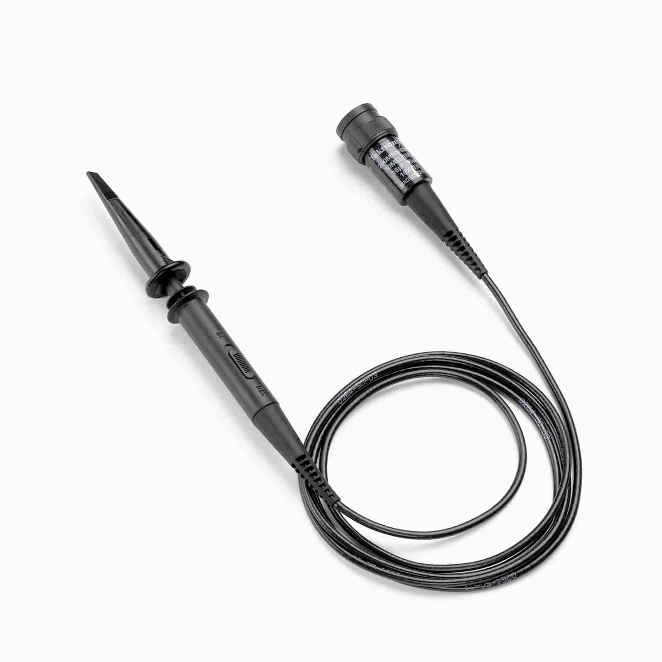
Figure 12: Tektronix P2221 Passive Probe.

P2221 Passive Voltage Probe
- 1X/10X Attenuation
- 200 MHz Bandwidth
- 1.5 Meter Length

10X Position 1X Position
Bandwidth DC to 200 MHz DC to 6 MHz
Input Capacitance 17 pF (typ) 110 pF (typ)
Input Resistance 10 MΩ 1 MΩ

Exercise
- Using a P2221 passive probe with the 10X attenuation selected, what is the approximate t_{r} value if R_{D} = 100 k?
t_{r} = ______________________________
Answer: t_{r} = 2.2 (100 kΩ x 17 pF) = 3.74 μsec
- Using a P2221 passive probe with the 1X attenuation selected, what is V_{meas} if R_{D} = 100 k and
V_{D} = 5 V?
V_{meas} = ______________________________
Answer: V_{meas} = (5 V) x [1 M  1 M, + 100 k,)] = 4.55 V

Active Probes
Active voltage probes include active components such as transistors and amplifiers and require power to operate. A simplified schematic of an active probe looks like this:
Figure 13: Active Probe Schematic.

Compared to passive probes, the advantages of active probes are:
- Low Input Capacitance
- Wide Bandwidth
- High Input Resistance
- Better Signal Fidelity

Compared to passive probes, the primary disadvantages of active probes are:
- Higher Cost
- Limited Dynamic Range
- Mechanically Less Rugged

Active probes have a very low input capacitance. As a result, the probe can maintain a high input impedance over a broad range of frequencies. The high input impedance of an active probe allows measurements at test points of unknown impedance with much less risk of loading effects. With low loading, active voltage probes can be used on high-impedance circuits that would be seriously loaded by passive probes. Also, active probes are less sensitive to the effects of inductance in long ground leads.

However, the active components do have a more limited maximum input voltage range due to limitations in the amplifier and its power supplies.

Compare the specifications for the recommended passive and active probes for the MSO/DPO2000 Series oscilloscopes:
Passive Probe Active Probe
P2221 (10X position) TAP1500
Attenuation 10X 10X
Bandwidth DC to 200 MHz DC to 1500 MHz
Input Capacitance 17 pF (typ) ≤1 pF
Input Resistance 10 MΩ 1 MΩ
Max. Input Voltage 300 V_{RMS} CATII ±8 V

Figure 14: Tektronix TAP1500 Active Probe.

As you can see, the probe’s shape, especially the probe tip is also very different from a passive probe. This smaller form factor and accessories make it easier to get the probe tip and ground much closer to small, surface-mounted components. Also note the larger box which connects to the oscilloscope. This box contains the power supply circuitry needed to power the active circuitry in the probe.

Exercise
- Using a P2221 passive probe with the 10X attenuation selected, what is t_{r} if R_{D} = 100 k?
t_{r} = ______________________________
Answer: t_{r} = 2.2 (100 kΩ x 17 pF) = 3.74 μsec
- Using a TAP1500 active probe, what is t_{r} if R_{D} = 100 k?
t_{r} = ______________________________
Answer: t_{r} = 2.2 (100 kΩ x 1 pF) = 220 nsec
- Which probe offers a faster rise time?
Answer: TAP1500 active probe.

Differential Probes
Passive and active voltage probes measure voltages relative to ground. Sometimes, it is necessary to measure the difference between two voltages where neither are at ground. These “differential” signals are referenced to each other instead of ground. Examples of differential signals are disk drive read channel signals, multi-phase power systems, and RS-422 and CAN data communication signals.

In some cases, you can measure differential signals by using two probes to make ground-referenced measurements and then using the oscilloscope’s math functions to subtract one channel from the other. This works if the signals are low frequency and have enough amplitude to rise above any concerns of noise.

However, this approach has problems. Any differences in propagation delay between the probes and oscilloscope channels will result in skewing of the signals. On high-speed signals, this especially can be a problem resulting in significant amplitude and timing errors. Also, any difference in gain or frequency response between the two channels will result in incomplete cancellation of “common-mode” noise or rejection of noise that is impressed on both signal lines by such things as nearby clock lines or noise from external sources such as fluorescent lights.

Figure 15: Differential Probe Schematic.

A differential probe, as shown here, uses a differential amplifier in the probe head close to the device to subtract the two signals, resulting in one differential signal for measurement by one channel of the oscilloscope. Because of the matching of the signal paths within the probe, a differential probe can provide very high “common mode rejection ratio” (CMRR) performance over a broad frequency range.

Compared to subtracting passive probe measurements, the advantages of active differential probes are:
- Wide bandwidth
- Large Common Mode Rejection Ratio (CMRR)
- Minimal skew between inputs
- Small input capacitance

Because they are active probes, the primary disadvantages of differential probes compared to passive probes are:
- Higher Cost
- Limited Dynamic Range
- Mechanically Less Rugged

As you can see in figures 16 and 17, the shape of the probe tip and even the accessories are specially designed to keep both inputs matched. The smaller form factor probe shown in figure 16 is designed for high frequencies and connection to microelectronic devices, while the probe shown in figure 17 is designed for high voltages and connection to large power components.
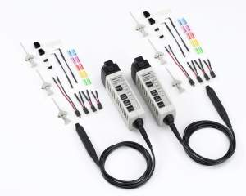  Figure 16: Tektronix TDP0500 & TDP1000 Differential Probes. | 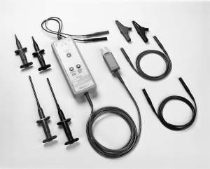  Figure 17: Tektronix P5205 High-Voltage, Differential Probe.

Current Probes
Voltage probes can be used to measure current flowing through a circuit by measuring the voltage drop (usually a differential measurement) across a known resistance (which may have to be added to the circuit). You then must divide the voltage by the resistance value to get the current.

There is a better way to make current measurements – a current probe. Current flow through a conductor causes an electromagnetic flux field to form around the conductor. Current probes are designed to sense the strength of this field and convert it to a corresponding voltage for measurement by an oscilloscope. This allows you to view and analyze current waveforms with an oscilloscope. When used in combination with an oscilloscope’s voltage measurement capabilities, current probes also allow you to make a wide variety of power measurements.

There are basically two types of current probes for oscilloscopes. AC current probes, which usually are passive probes, and AC/DC current probes, which are generally active probes. Both types use the same principle of transformer action for sensing alternating current (AC) in a conductor. AC/DC probes have an additional device, known as a Hall Effect device, for detecting DC since DC doesn’t cause a changing flux field and, thus, cannot cause transformer action.

There are also basically two form factors for current probes, split-core and fixed-core. With a fixed core current probe, the conductor to be measured must be fed through the conductor of the transformer on the probe then reconnected to the device. The advantage of a fixed-core probe is its high frequency response for measuring very fast, low amplitude current pulses and AC signals. Split-core current probes, like the ones shown below, allow the probe to encircle the conductor. These probes offer significantly simpler connection to most circuits.

Another important feature of some current probes is automatic scaling. With current probes such as those shown below, the probe communicates the proper scale factors and units so the oscilloscope displays the waveforms and measurements with the proper units (for example, Amperes).

As you can see in the pictures below, the split-core probe tips are designed to clamp around a conductor. The smaller form factor current probe is designed for currents up to 30 ARMS / 50 A_{peak} and frequencies ≥120 MHz, while the other probe shown is designed for higher currents (up to 150 ARMS / 500 A_{peak}) at frequencies up to 20 MHz and connection to much larger conductors.
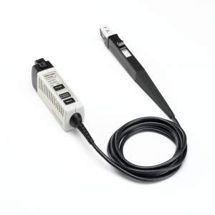  Figure 18: Tektronix TCP0030 Current Probe. | 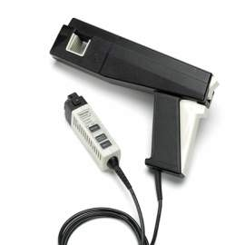  Figure 19: Tektronix TCP0150 Current Probe.

Key Points to Remember
- Passive probes are relatively inexpensive and mechanically rugged; however, they tend to have high input capacitance.
- Active probes provide low input capacitance. They are a good solution for measuring high frequency signals or high impedance circuits because they can maintain high input impedance over a wide range of frequencies.
- A differential probe provides a large common mode rejection ratio (CMRR) and minimal skew between inputs for measuring differential signals.
- A current probe is used to make current measurements. Some current probes can only detect AC current. To measure DC current, an AC/DC current probe is required.

Exercise
- You need to measure the voltage across a device, where neither voltage is at ground. What probe type should you use?
Answer: Differential voltage probe.
- You need to measure the current flowing through a device. What probe type should you use?
Answer: Current probe.

- If you need to test a high frequency circuit, what type of probe do you probably need?
Answer: Active probe.

Using a Passive Probe

Probe Compensation Adjustment
- The following steps discuss and demonstrate the proper procedure for adjusting an oscilloscope probe. For best signal fidelity, this procedure should be performed each time the probe is connected to the oscilloscope.
  - Power up the oscilloscope by pressing the power switch on the lower left corner of the instrument.
  - Press the front-panel Default Setup button to set the oscilloscope to a known state.
  - Connect a P2221 1X/10X passive probe to the channel 1 input. To connect a BNC connector, push and turn the probe connector until it slides on the connector. Then, turn the locking ring clockwise to lock the connector in place.
- To minimize the loading effect of the probe, use the 10X setting for this part of the lab.
  - Use the slider switch on the probe to set the probe attenuation to 10X.
- For the oscilloscope to make correct measurements, it must know the attenuation of each of the probes. Some probe / oscilloscope combinations will set this automatically; others may require you to manually set the attenuation. In the case of the P2221 1X/10X probe, it must be done manually.
  - Press the yellow 1 button to show the channel 1 menu.
  - Verify that the readout at the bottom of the display shows that the oscilloscope is set up for a 10X probe.
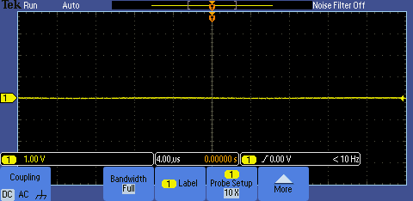
  - Attach the black probe ground lead to the ground connector on the lower right corner of the oscilloscope. Squeeze the widest part of the ground connector to open the alligator jaws. Attach to the connector.
  - Attach the probe tip to the PROBE COMP signal next to the ground. Hold the probe like a syringe and pull back on the spring-loaded tip to expose the probe’s hook tip. Attach to the connector.
  - Press the front-panel Autoset button to automatically set up the oscilloscope.
- Probes are designed to match the inputs of specific oscilloscope models. However, there are slight variations between oscilloscopes and even between different input channels in an oscilloscope. To minimize these variations, you must “compensate” a passive probe every time you change a probe/channel connection of your oscilloscope. Compensation is the process of manually adjusting the AC attenuation by adjusting the ratio of the capacitances which appear in parallel with the probe’s attenuator resistances.
  - Find the adjustment tool provided with the probe or other small, non-magnetic screwdriver.
  - Insert the probe adjustment tool in the small hole in the probe body near where the probe is attached to the oscilloscope BNC input connector.
  - Slowly turn the adjustment until the oscilloscope is displaying the calibration waveform with flat tops with no overshoot or rounding.
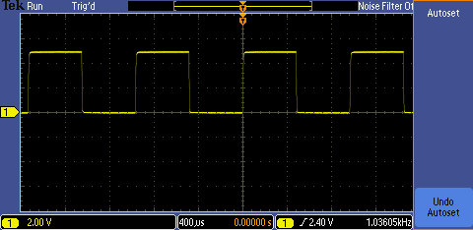
  - An over-compensated probe might look like this:
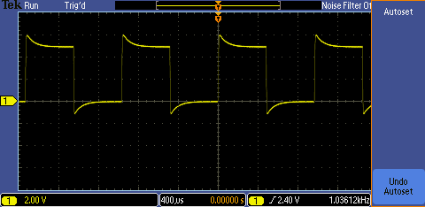
  - An under-compensated probe might look like this:
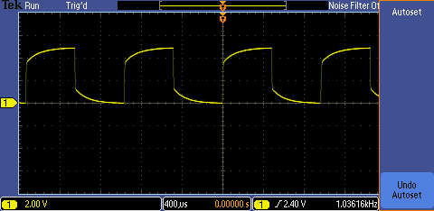

Key Points to Remember
- To reduce the loading effect of a probe on a signal test point, the signal amplitude transmitted to the oscilloscope input must be reduced, or attenuated.
- For the oscilloscope to make correct measurements, it must know the attenuation of each of the probes. You may need to do this manually.
- You must “compensate” a passive probe every time you change a probe/channel connection of your oscilloscope. Compensation is done by connecting the probe to a square wave signal and then adjusting the shape of the signal to a square wave.

Different Probing Methods
- In the next series of steps, you will change the probe attenuation factor to 1X. Remember, to make accurate measurements, the oscilloscope must know the probe’s attenuation factor.
  - With the slider switch on the probe, set the probe attenuation to 1X. Notice that the waveform on the oscilloscope display has increased in size. Since the 1X position has a lower attenuation, the voltage measured by the oscilloscope has increased.
Probe slider switch set to 10X:
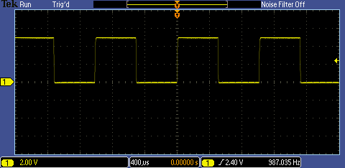
Probe slider switch set to 1X:
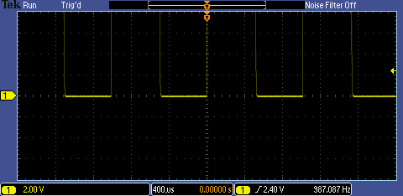

  - Press the yellow 1 button to show the channel 1 menu.
  - Press the Probe Setup bottom bezel button to display the Probe Setup side menu.
  - Press the Set to 1X side bezel button.
  - Verify that the readout at the bottom of the display shows that the oscilloscope is set up for a 1X probe.
  - Press the front panel Autoset button. Notice that the waveform on the display now is smaller and is accurately shown as being a 5V pulse. The oscilloscope is now properly compensating for the probe attenuation.
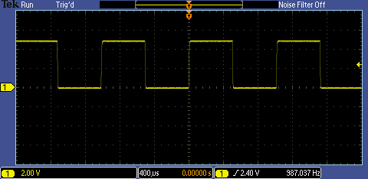
- There are a variety of ways to connect a probe to a circuit. The technique using the spring-loaded tip works well for connecting to many test points, square pin connectors and individual wires. When troubleshooting a circuit, it is often easier to use a sharp probe point. This allows you to accurately position the probe tip on fine-pitch components as will be demonstrated in the following steps.
  - Disconnect the probe ground from the ground connector.
  - Remove the probe tip from the PROBE COMP signal connector.
  - Gently pull on the probe tip until the end comes off.
  - Re-attach the probe ground lead to the ground connector.
  - Touch the sharp probe tip to the PROBE COMP signal and verify that the same signal appears on the display.
  - Gently push the probe tip back on the probe.
  - Connect the channel 1 probe tip to the PROBE COMP signal again.
- It is important to verify that the probe is not loading the signal too much. One simple way to do this is to watch the signal as a second probe is added. In the following steps, notice that as you touch the channel 2 probe to the PROBE COMP signal, the display is basically unchanged; indicating that the second probe is not significantly loading the signal.
  - Connect second P2221 1X/10X passive probe to the channel 2 input.
  - Attach the channel 2 black probe ground lead to the ground connector on the lower right corner of the oscilloscope.
  - Touch the channel 2 probe tip to the PROBE COMP signal.
  - As you touch the channel 2 probe to the PROBE COMP signal, you should see that the display is basically unchanged, indicating that the second probe is not significantly loading the signal.

Key Points to Remember
- There are a variety of ways to connect a probe to a circuit.
- A spring-loaded tip works well for connecting to many test points, square pin connectors and individual wires.
- When troubleshooting a circuit, it is often easier to use a sharp probe point. This allows you to accurately position the probe tip on fine-pitch components.
- It is also important to verify that the probe is not loading the signal too much. One simple way to do this is to watch the signal as a second probe is added.

Final Exercise
- An oscilloscope probe is:
  - Just a wire.
  - Usually just a coaxial cable.
  - A complete circuit consisting of passive and possibly active electronic components.
  - Unnecessary for most measurements.
Answer: c
- You should choose your oscilloscope probe by:
  - Use the one that is already connected to the oscilloscope.
  - Choose the right probe, based on the circuit impedance and signal frequency and amplitude.
  - Grab the first one you see in the bench drawer.
  - Distract the person next to you and take theirs.
Answer: b
- Oscilloscope probes are characterized by:
  - Bandwidth.
  - Maximum voltage rating.
  - Input capacitance.
  - All of the above.
Answer: d
- Probes can connect to various:
  - Test points.
  - Connectors.
  - Component leads.
  - All of the above.
Answer: d
- Probes can affect the quality of electronic measurements by:
  - Adding DC loading, because of the probe’s input resistance.
  - Adding AC loading, because of the probe’s input capacitance.
  - Changing the shape of the waveform because of the probe’s bandwidth.
  - All of the above.
Answer: d
- This final exercise will require the use of the skills and knowledge gained to this point.
- Begin by using the USB cable to connect the demonstration board to the oscilloscope’s USB port as shown in the figure to the right. | 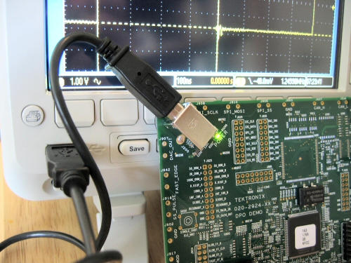
  - Connect both P2221 oscilloscope probes to channel 1 and channel 2. Set the 1X/10X slide switch on both probes to 10X.
- Connect the vertical channel 1 probe’s alligator ground tip to the GND connector and the probe tip to the pin labeled CNT_CLK as shown in the figure to the right. |  | 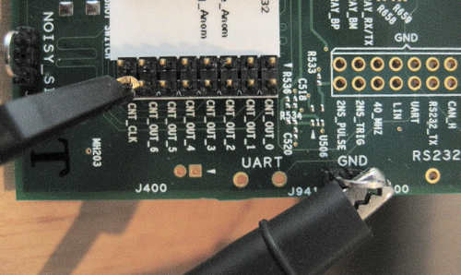
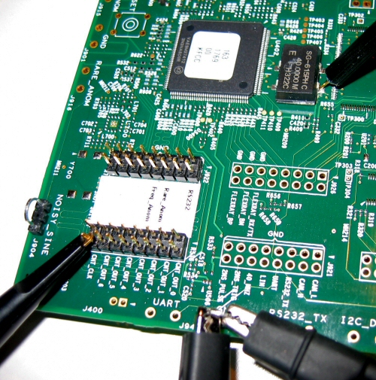
  - Use the vertical channel 2 probe’s alligator ground clip to the GND connector and view the signal at the point shown in the figure.
  - Set up the oscilloscope for the following display:
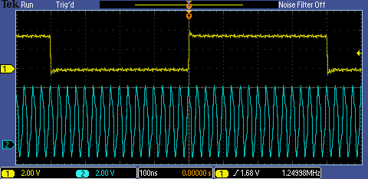
  - Describe the basic steps needed to create the previous display.
    - Press the Default Setup button.
    - Turn on channel 2 by pressing the blue 2 front panel button.
    - Adjust the channel 1 vertical scale to 2 V/div.
    - Adjust the channel 2 vertical scale to 2 V/div.
    - Adjust the channel 1 and channel 2 vertical positions.
    - Set the horizontal scale to 100 ns/div.
    - Adjust the trigger level to 1.58 V.
    - Press the Menu Off button.

Tektronix products are covered by U.S. and foreign patents, issued and pending. Information in this publication supersedes that in all previously published material. Specification and price change privileges reserved. TEKTRONIX and TEK are registered trademarks of Tektronix, Inc. All other trade names referenced are the service marks, trademarks or registered trademarks of their respective companies.
06/09 GB/WWW 3GW-24322-0 Guide

