FILM (Negative)
(For ILFORD Ortho Plus copy film)

Use Kodak #2 filtered safelight over the developing trays. The brighter Kodak #1A could fog the film during development.
Load the film in total darkness or under #2 filtered safelight. A very brief exposure to the #1A safelight is okay when unloading the film.
The standard temperature for all solutions is 20°C/68°F (18°C/65°F to 24°C/75°F range).
The times indicated in the table are good for solutions at ambient temperature except for the running waters (68°F).

Develop | 1 part Kodak D76 stock solution to 1 part water.  Stock solution: 3 L water, D76 powder, mix well before filling water to 1 gallon.  Capacity: 8 (8x10 sheet) per gallon of 1:1 solution.  500 ml to 500 ml ratio for eight (8) 4x5” films.  Discard solution and make a fresh solution each time. | 5 min  (~ 11 min for G0.70)  Continuous agitation
Stop | 2 capfuls of acetic acid to 1 tray of water.  (48 ml of 28% acetic acid to 1L water) | 30 sec  Continuous agitation
Fix | Undiluted KODAK PROFESSIONAL Rapid Fixer stock solution.  Stock solution: 1 part Rapid Fixer Part A concentrate to 3 part water plus Part B hardener.  Capacity: 120 8x10” sheets per gallon of or 126 4x5” films per L of undiluted stock solution  600 ml for seventy six (76) 4x5” films.  Replenish as needed – lasts for 1 week. | 4 min  (2 min ~)  Continuous agitation for 30 sec  then 30 sec interval
Wash 1 | running water | 30 sec  (~ 2 min)
Wash 2 | 1 capful of Permawash to 1 tray of water.  Wash aid – promotes removal of fixer and shorten wash time. | 30 sec  (~ 1 min)  Continuous agitation for 30 sec  then 30 sec interval
Wash 3 | running water  (1 tray / 5 min) | 1 min  (~ 2 min)
KODAK D-76 Developer (To make 1 gallon) CAT No.146 4817
KODAK PROFESSIONAL Rapid Fixer (a hardening fixer)
Last updated: April 15, 2005
PHOTOGRAPHIC PAPER
(For Kodak Polymax II RC exposed for 2~4 sec w/ smallest aperture f/5.6 on Beseler 45 MXT)

Kodak #1A filtered safelight does not affect the photographic paper.
Dry the developed paper in the forced-air dryers under medium heat. If you must use the drum dryer, use the maximum temperature of 175°F and put the emulsion side of the paper away from the drum.
The standard temperature for all solutions is 20°C/68°F (18°C/65°F to 24°C/75°F range).
The times indicated in the table are good for solutions at ambient temperature except for the running waters (68°F).

Develop | 1 part Kodak DEKTOL stock solution to 2 parts water.  Stock solution: Follow package instruction.  Capacity: 120 8x10” sheets per gallon of 1:2 solution.  95 ml to 189 ml ratio for nine (9) photos. (used to be160:320)  Discard solution and make a fresh solution. | 1 min  (3/4 to 3 min for RC papers)  Continuous agitation
Stop | 2 capfuls of acetic acid to 1 tray of water.  (48 ml of 28% acetic acid to 1L water) | 10 sec  Continuous agitation
Fix | 1 part Kodak Rapid Fixer stock solution to 1 part water.  Stock solution: Follow the package instruction for film, not paper.  Capacity: 100 8x10” sheets per gallon of 1:1 concentrate:water ratio.  170 ml to 170 ml ratio for eight (8) photos and eight (8) test strips. (old ratio 250:250)  Replenish as needed – lasts for 1 week. | 2 min  Continuous agitation for 30 sec then 30 sec interval
Wash 1 | running water | 30 sec  (~ 45 sec)
Wash 2 | 1 capful of Permawash to 1 tray of water.  Wash aid – promotes removal of fixer and shorten wash time. | 30 sec  (~ 45 sec)  Continuous agitation for 30 sec then 30 sec interval
Wash 3 | running water  (1 tray / 5 min) | 30 sec  (~ 45 sec)

Last updated: April 15, 2005

We use the ILFORD Ortho Plus orthochromatic copy film. The film is insensitive to red safelight which allows students to see the developing processess. For detailed product information, consult ILFORD home page or “http://www.ilford.com/html/us_english/pdf/ortho_plus_web.pdf”.

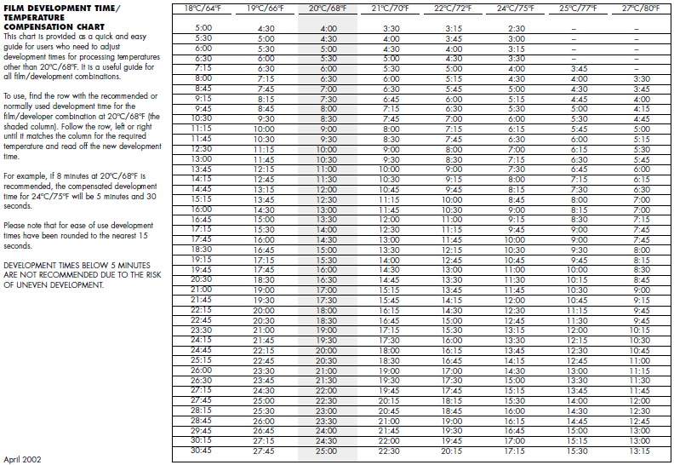
From ILFORD Temperature Compensation Chart (http://www.ilford.com/html/us_english/pdf/tempconv.pdf)

