109 Quiz 11: Week 12 Name_________________

1. White light passes through a yellow filter and a magenta filter. What color is transmitted? Does the order of the filters matter?

2. White light passes through a blue filter and a red filter. What color is transmitted?

3. Draw the reflectance curve for a banana.

4. You mix 2 parts magenta paint with 1 part yellow paint. What color do you see?

1. White light passes through a yellow filter and a magenta filter. What color is transmitted? Does the order of the filters matter?
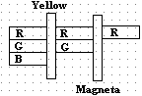 Red light and order does not matter

2. White light passes through a blue filter and a red filter. What color is transmitted?

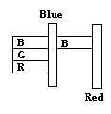 No light is transmitted.

3. Draw the reflectance curve for a banana.

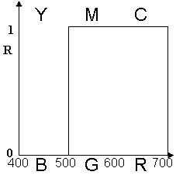 A banana appears yellow

4. You mix 2 parts magenta paint with 1 part yellow paint. What color do you see?
B
G
R
Y
M
C
Reflectance
1
0
B
G
R
Y
M
C
Reflectance
1
0
0
0.2
0.4
0.6
0.8
1
0
0.2
0.4
0.6
0.8
1
fraction of red
fraction of green

We have 1 part blue and 2 parts red left over. So our color formula is S=0.5B+0G+1R with r = 0.67 and g = 0. Our color, which is indicated by the large circle, is a reddish magenta.

