This lab ran for two weeks and focused on changes in energy and momentum of two interacting bodies. Students set up two opposing Motion Detectors at opposite ends of the track, each monitoring a cart throughout a collision as shown below. The Detectors were set for close range and the aluminum reflectors were replaced with cardboard taped to the ends of the carts. This seemed to significantly reduce noise in the data, a sample of which is shown below.
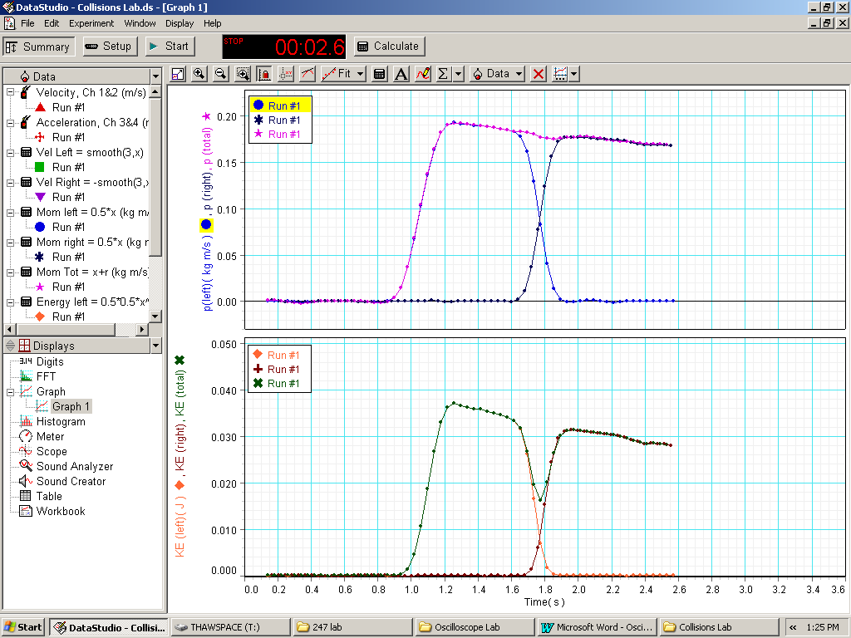
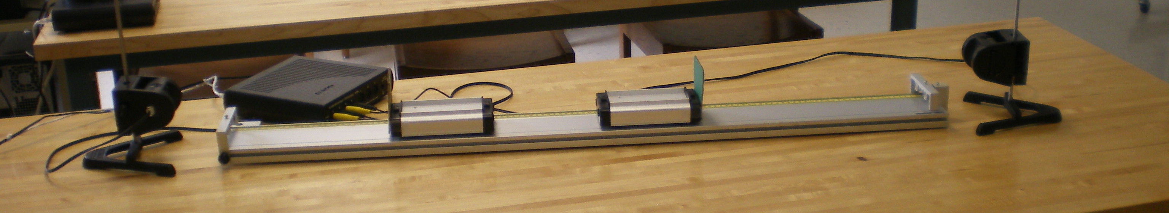
Here two equal mass carts, one at rest, are collided and the momenta and energies of both as well as the totals were plotted. This Data Studio Activity is saved within this folder and it can be used for any type of collision. If different masses are added the Calculated data needs adjustment. 247 students spent time learning to use Data Studio so they could display the data in useful ways. The dip in the total KE is a very interesting thing to try to understand. Comparison with the inelastic case revealed some interesting insights on energy and its conservation during a collision. That experimental data is shown below.

Students can explore friction and impulse as well.
