Collisions

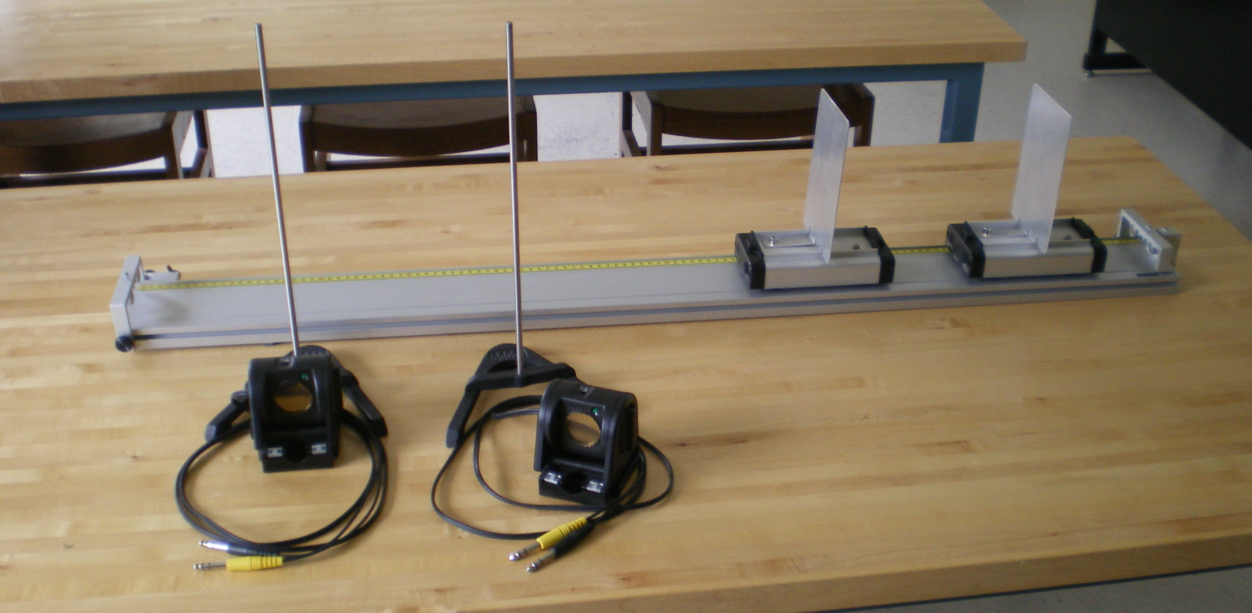

Each Set-Up contains:

1 Track
2 Mag-NoMag Carts
2 Motion Detectors
2 Detector stands
Also:

