Introduction to the Oscilloscope

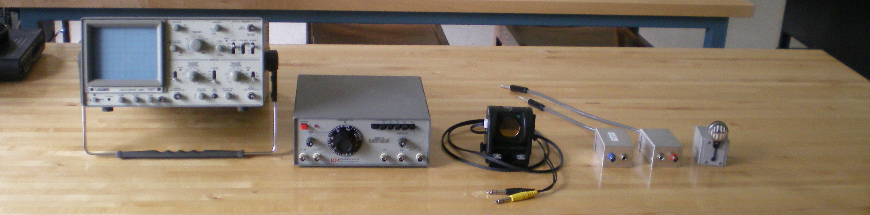

Each Set-Up contains:

1 Oscilloscope
1 Function Generator (Krohn-Hite)
1 Motion Detector
2 Pull-Off Boxes
1 Microphone
Also:
1 Oscilloscope Manual

