This lab explored the relationship between force and energy in cases of springs and rubber bands. Students examined force vs. displacement curves and measured the energy losses in rubber bands and compared them to springs. The Motion Detector was set for close range. There is a Data Studio Activity saved in this folder that has the sensor input sent to a graph. The displacement must be Calculated in Data Studio to get the initial position set to zero and increasing as the reflector is brought nearer to the detector. When switching between rubber bands and springs of different length you need to reset the motion sensor is setup. Force needs to be inverted also as a pull gives a negative reading.
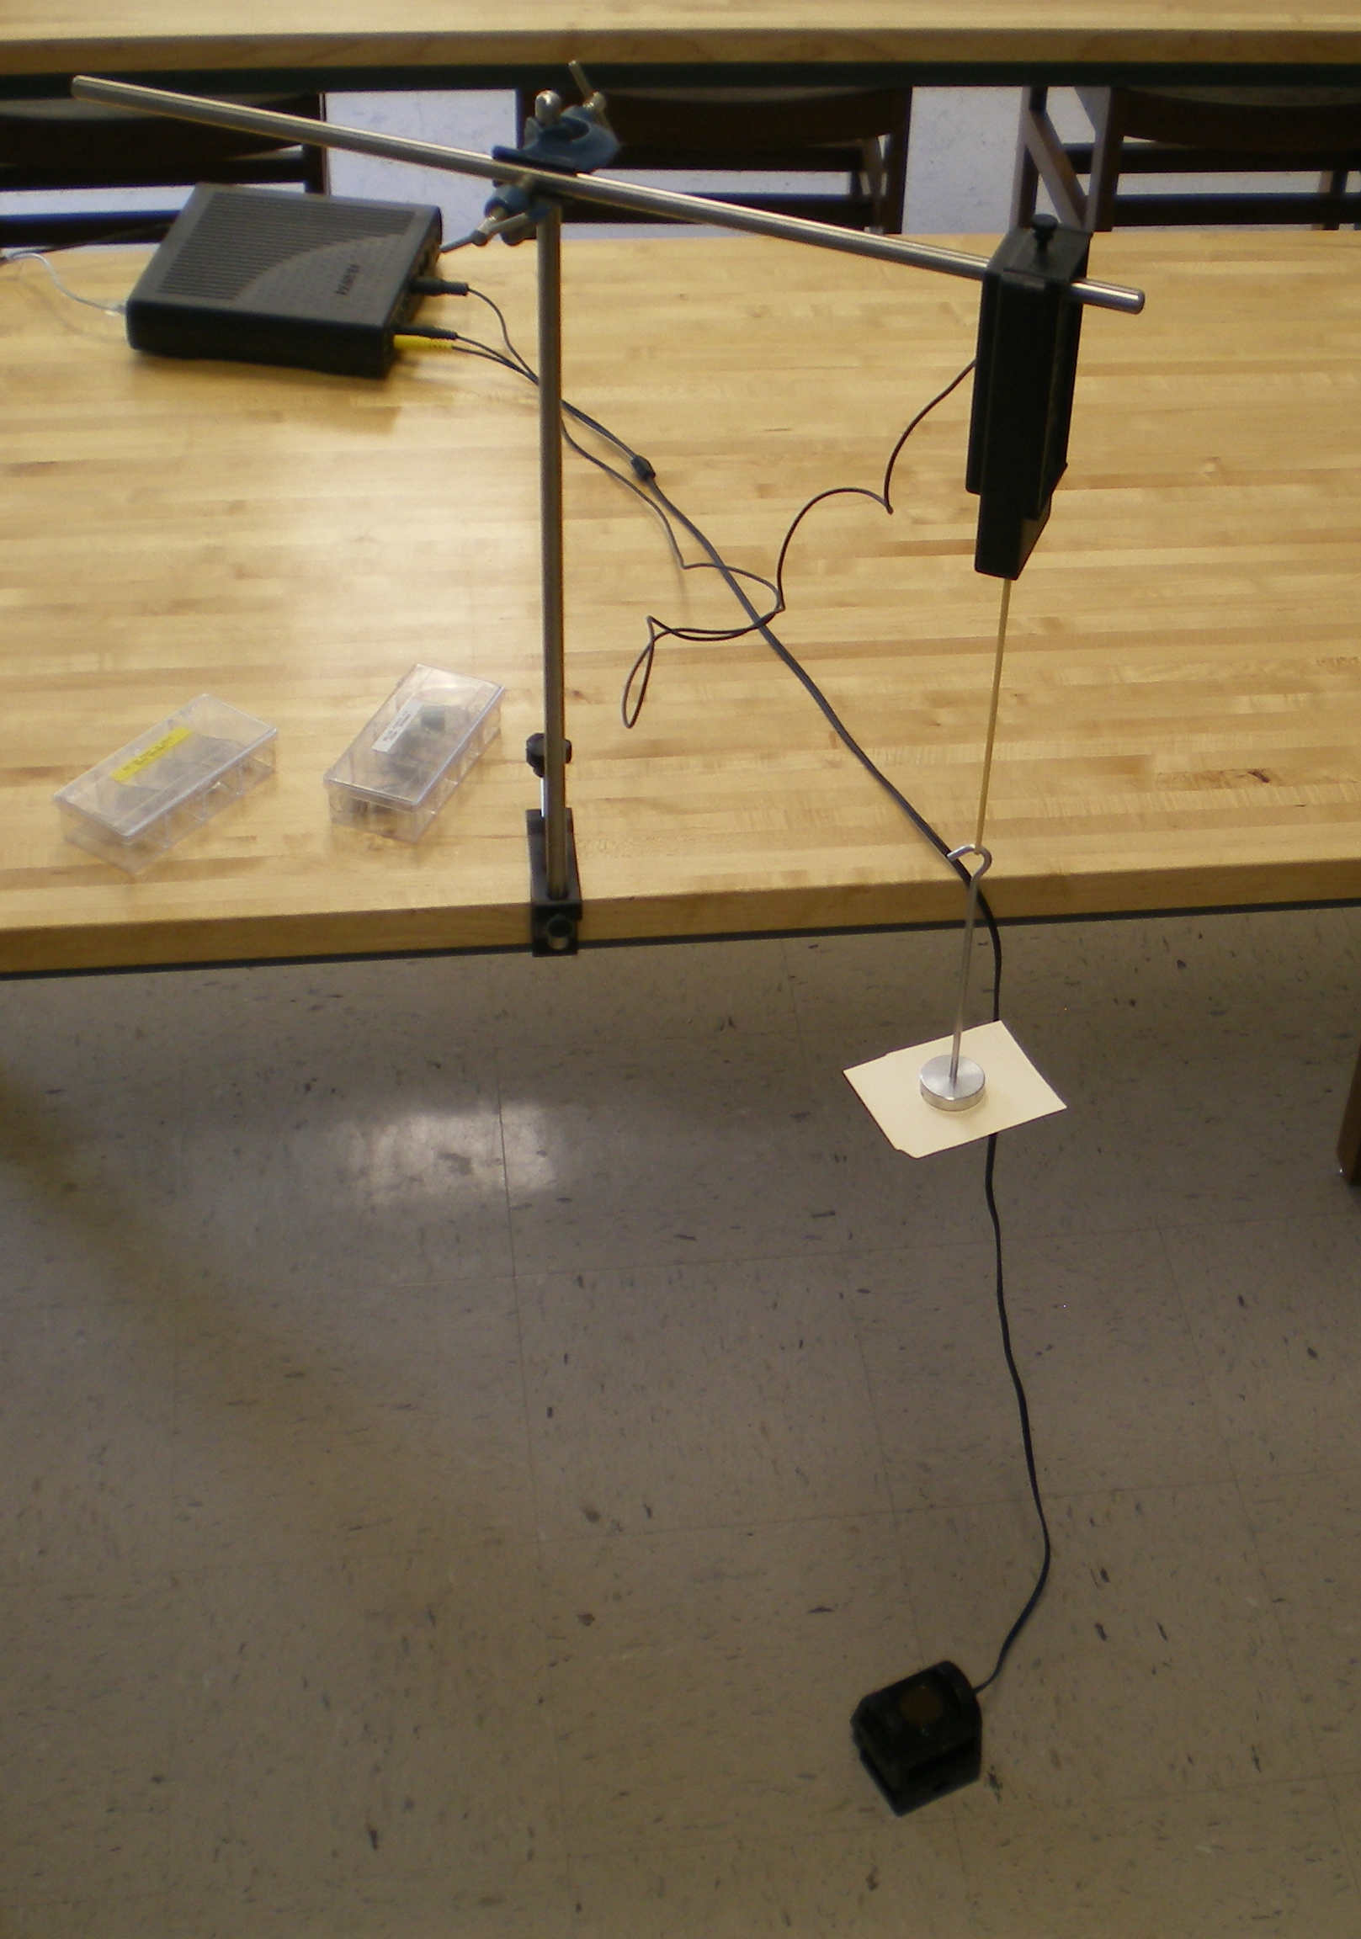

Students calculate (from the graph) the energy (Work) done on the way out and back and discuss the implications of the rubber band’s curve. The rubber band is not a conservative system and so is not a good candidate for potential. An example of the data is shown below.

