Potential Energy

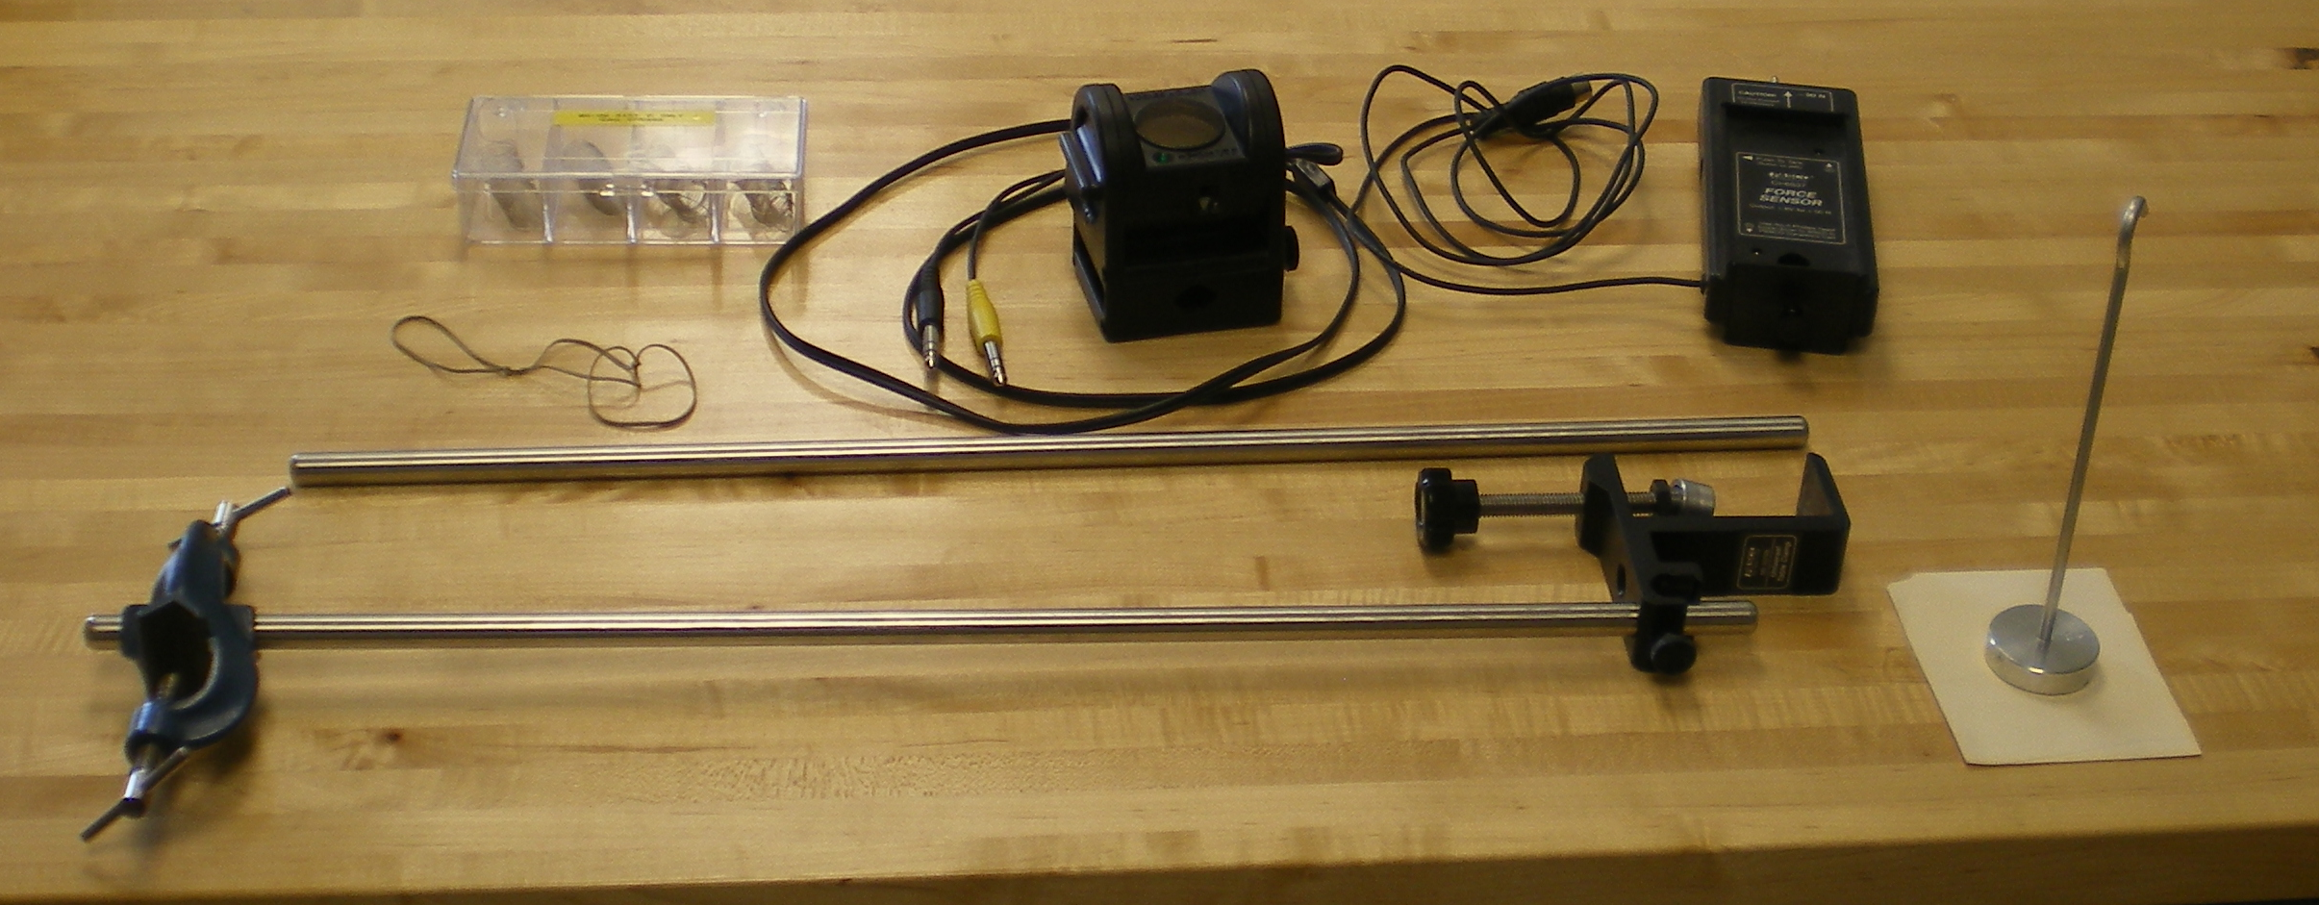

Each Set-Up contains:

1 Motion Detector
1 Force sensor
1 Universal Table Clamp
1 Right Angle Clamp
2 ½” X 2’ Bars
1 12mm Spring Set (Each group needs 2 springs so 1 set of 4 for 2 groups)
Assorted Rubber Bands (Very light)
1 Hanging Mass holder (usually already in room)
Also:

